SYDNEY WESTERN CITY PLANNING PANEL
Section 4.15 Assessment Report

Panel Reference | PPSSWC-490
DA Number | DA0409/24
LGA | Hawkesbury City Council
Proposed Development | Subdivision - Staged subdivision to create 256 Torrens Title Residential Lots and Civil works associated with the creation of the lots and delivery of supporting infrastructure. The application includes the provision of urban infrastructure to the proposed lots and new internal roads with intersection treatment to Spinks Road.  The application has been lodged as ‘Nominated Integrated Development’ under Section 4.46 and Clause 7(2) in Division 1 of Schedule 1 of the Environmental Planning and Assessment Act 1979 as the proposal requires general terms of approval under Section 100B of the Rural Fires Act 1997 and Section 91 of the Water Management Act 2000.  The determining authority for the Development Application will be the Sydney Western City Planning Panel.
Street Address | - (Lot 206 DP 1268299, Lot 205 DP 1268299, Lot 210 DP 1268299), No.361 Spinks Road GLOSSODIA
Applicant/Owner | Applicant: Mr M Johnson  Owners:  - Pace Land Holdings Pty Limited  - Printsilk Pty Limited  - Himbla  - Rashka Pty Limited  - Feecha Pty Limited
Date of DA lodgement | 13 September 2024
Total number of Submissions | Three (3)
Recommendation | Approval
Regional Development Criteria | Development that has a capital investment value of more than $30 million.
List of all relevant s4.15(1)(a) matters | - Environmental Planning and Assessment Act 1979;  - Environmental Planning and Assessment Regulations 2021;  - Biodiversity Conservation Act 2016;  - Environmental Protection and Biodiversity Conservation Act 1999;  - National Parks and Wildlife Act 1974;  - State Environmental Planning Policy – (Biodiversity & Conservation) 2021 ;  - State Environmental Planning Policy (Resilience & Hazards) 2021;  - State Environmental Planning Policy (Transport & Infrastructure) 2021;  - Hawkesbury Local Environmental Plan 2012 (LEP 2012);  - Hawkesbury Development Control Plan 2002 (HDCP 2002); and  - Hawkesbury Council Flood Policy 2020
List all documents submitted with this report for the Panel’s consideration | - Design Report - Glossodia West Development Application DA1 Stage 1-3  - Stormwater management strategy – Glossodia West Stage 1-3  - The design partnership Crime Prevention through Environmental Design (CEPTED) Report  - Glossodia Development DA1 Residential subdivision Traffic Impact Assessment Report  - Road Safety Audit  - Bushfire Assessment Residential subdivision Glossodia West DA1 Stages 1-3  - Aboriginal Heritage Impact Permit 5241 – Jacaranda Subdivision and Residential development.  - Completion of Archaeological fieldwork PACE Jacaranda subdivision and residential development Aboriginal Heritage Impact Permit 5241.  - EDC Cost Report  - Statement of Environmental Effects.
Clause 4.6 requests | - N/A
Summary of key submissions | Key items:  - Stormwater  - Traffic
Report prepared by | Matthieu Santoso – Senior Town Planner
Report date | 9 May 2025
Summary of s4.15 matters  Have all recommendations in relation to relevant s4.15 matters been summarised in the Executive Summary of the assessment report? |  | Yes
Legislative clauses requiring consent authority satisfaction  Have relevant clauses in all applicable environmental planning instruments where the consent authority must be satisfied about a particular matter been listed, and relevant recommendations summarized, in the Executive Summary of the assessment report?  e.g. Clause 7 of SEPP 55 - Remediation of Land, Clause 4.6(4) of the relevant LEP |  | Yes
Clause 4.6 Exceptions to development standards  If a written request for a contravention to a development standard (clause 4.6 of the LEP) has been received, has it been attached to the assessment report? |  | Not applicable
Special Infrastructure Contributions  Does the DA require Special Infrastructure Contributions conditions (S7.24)?  Note: Certain DAs in the Western Sydney Growth Areas Special Contributions Area may require specific Special Infrastructure Contributions (SIC) conditions |  | Not applicable
Conditions  Have draft conditions been provided to the applicant for comment?  Note: in order to reduce delays in determinations, the Panel prefer that draft conditions, notwithstanding Council’s recommendation, be provided to the applicant to enable any comments to be considered as part of the assessment report |  | Yes

1. Executive Summary

On the 15 December 2023, the Sydney Western City Planning Panel approved DA0266/23 which granted the approval of a Concept Masterplan and Stage 1 works for ‘Jacaranda’. The concept masterplan provided for the staged subdivision of 580 residential lots and associated infrastructure.

The Concept Masterplan involved the identification of land uses throughout the subject development site and also details of the internal road layout, external connections, street hierarchy, the location of the local water centre, as well as the general location and form of the water cycle management basins. It is noted that the concept masterplan comprises of four (4) precincts that have been premised on the basis of site constraints, land ownership, access arrangements, ecosystem credit offsets and retirement and servicing.

It is noted that the Jacaranda Estate was originally rezoned from RU1 Primary Production to urban purposes on 19 December 2014. The masterplan for the site incorporated both R2 Low Density Residential and R5 Large Lot Residential zones achieving a residential yield of 580 lots. The rezoning also included RE1 Public Recreation and SP2 Infrastructure zones that would support the community needs and servicing for the future population. The masterplan however was revised with a further Planning Proposal which reconfigured the land use zones while incorporating a C2 Environmental Conservation zone while retaining the 580 residential lot yield. Council, at its meeting on 27 April 2021 resolved to adopt the revised masterplan and accompanying land use zones which was gazetted to the Hawkesbury Local Environmental Plan 2012 on 30 September 2021.

A new Voluntary Planning Agreement (VPA) is currently being negotiated with Council for the Jacaranda development which will replace a previous VPA. The draft VPA proposes an increase in contributions from the existing VPA per lot in cash and/or works in kind and/or dedication of land.

The subject application seeks the delivery of two hundred and fifty-six (256) lots to Precincts C & D of Jacaranda inclusive of earthworks, tree removal and the delivery of road and streetscape infrastructure under a staged format.

The subject Development Application has been assessed having regard to the applicable planning controls and it is considered that the proposed development is satisfactory. In this respect, it is recommended that the subject Development Application be approved, subject to conditions.

2. Background

2.1 Planning Proposal (2014)

A Planning Proposal was gazetted on the 19 December 2014 which sought to amend the following items under the then Draft Hawkesbury Local Environmental Plan 2012:

- Rezoning of the stie from RU1 Primary Production to R2 Low Density Residential, R5 Large Lot Residential, RE1 Public Recreation & SP2 Infrastructure (Sewage Systems); and
- The introduction of a 10m height limit across the zones; and
- The introduction of minimum subdivision lot sizes ranging from 1,000m², 2,000m² & 4,000m² across the site.

These amendments were informed by a Concept Masterplan illustrated in Figure 1 which was intended to guide the future subdivision and development of the site and provide for:

- A total of 580 residential allotments;
- The creation of new public open spaces within the North-Eastern portion of the site to accommodate walking and cycling, and spaces for active and passive recreation;
- Planting and rehabilitation of the riparian corridor along the entire Currency Creek boundary of the site;
- Three North-South ecological corridors and an East-West ecological corridor;
- The provision of infrastructure through the execution of both a State and local Voluntary Planning Agreement
- The retention of two large dams on site.

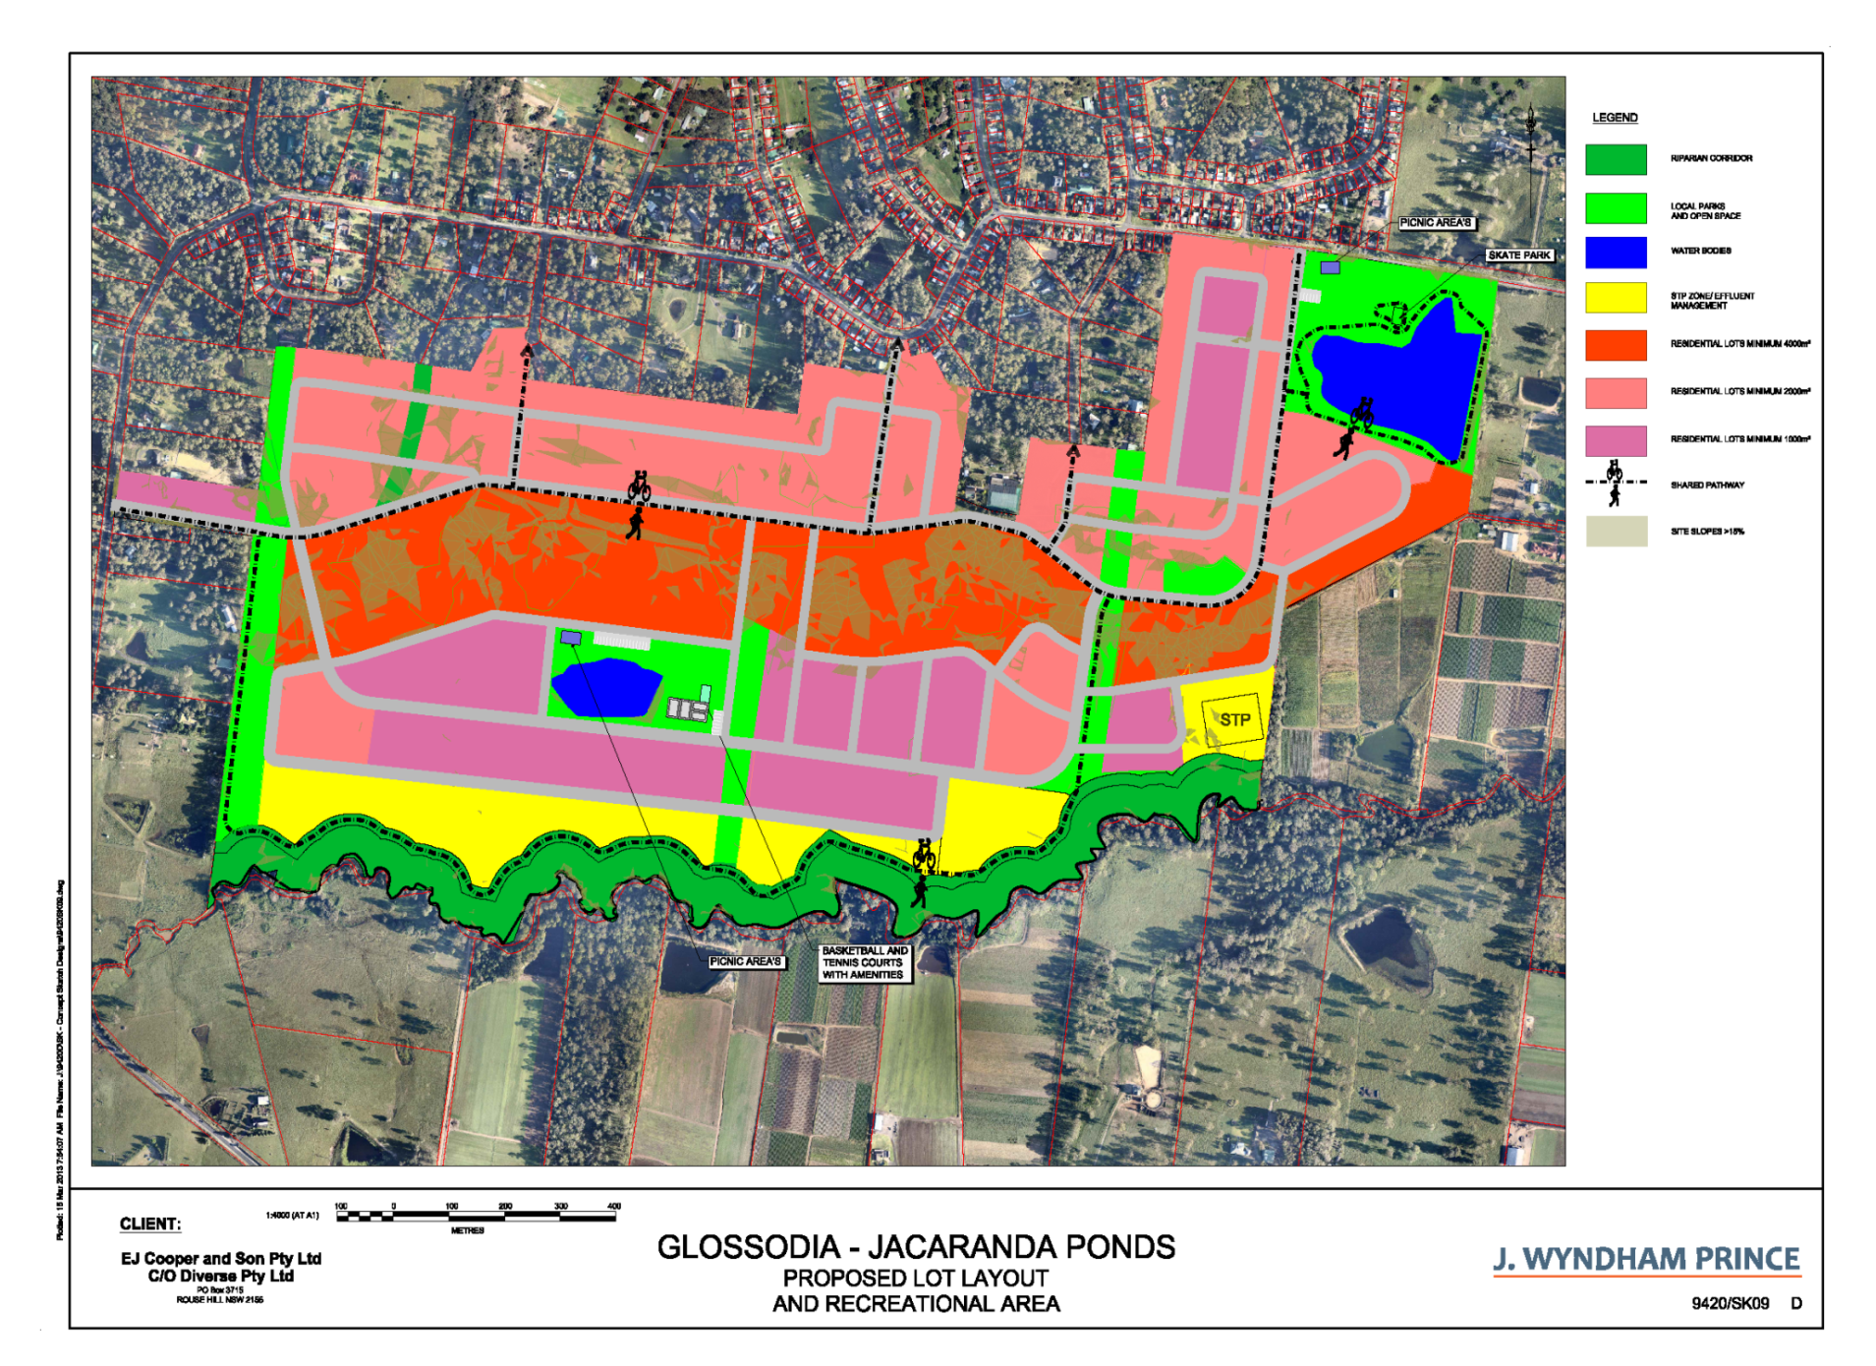Figure 1. Previous Concept Masterplan
Village Green
Residential
(1,000m² lots)
Lakeside Park
Shared pathway
Riparian corridor
Residential
(4,000m² lots)
Residential
(2,000m² lots)
Future road/pedestrian links
(2,000m² lots)
Riparian corridor
Shared pathway
SP2 Infrastructure
(Sewerage Works)
The Planning Proposal was accompanied by an offer from the applicant to enter into a Voluntary Planning Agreement (VPA) for the delivery of local and regional infrastructure. It provided for contributions towards local infrastructure to support the development and its future population, as well as contributions towards the upgrading of the regional road network.

2.2 Voluntary Planning Agreements
The planning proposal was accompanied by a Local VPA to the value of $17.4 million ($30,000 per lot subject to CPI indexation) for the delivery of the required local and regional infrastructure to support approximately 580 lot yield on the subject site. The Local VPA was executed in January 2017, and is included as Attachment 2 of this Report.

A State VPA enabling a total of approximately $5.8 million Development Contributions ($10,000 per lot subject to CPI indexation) for improvements to State road network was also executed between the Developer and the then Department of Planning and Infrastructure.

The VPA would operate in lieu of a Section 7.11 or Section 7.12 Development Contributions during such a time where residential construction is to commence within the Jacaranda Precinct.

2.3 Planning Proposal (2018)
A subsequent Planning Proposal was submitted for the Jacaranda site which sought the following:

- Rezone part of R5 Large Lot Residential and RE1 Public Recreation zoned land to E2 Environmental Conservation and reconfigure part of RE1 Public Recreation zoned land containing significant vegetation and endangered habitat within the subject site to achieve improved ecological outcomes for the subject site.

- Rezone SP2 Infrastructure zoned land (other than a small area of SP2 zoned land at the south-eastern corner of the subject site proposed for a water recycling facility) along the Currency Creek corridor to part R2 Low Density Residential and RE1 Public Recreation.

- Reconfigure the R2 Low Density Residential, the remainder of R5 Large Lot Residential land and RE1 Public Recreation zoned land to yield approximately 580 residential lots on the subject site .

On 27 April 2021, Hawkesbury City Council resolved to adopt the Planning Proposal through an LEP amendment on the 30 September 2021.

2.4 Draft Local Planning Agreement
A new VPA is currently being negotiated with Council for the Jacaranda development which will replace the current VPA. The Draft VPA proposes an increase in contributions from the existing VPA to $40,000 per lot in cash and/or works in kind and/or dedication of land.

On 30 July 2024, an amended VPA was provided to Council which sought to increase the contributions from $30,000 per lot to $40,735 per lot (consisting of cash and public works) to a total of $11,405,852.

Whilst not formally executed at this point in time, the VPA is to be reported to Council shortly and if adopted, would supersede the existing VPA arrangement.

2.5 Concept Masterplan Approval
DA0266/23 was approved by the SWCPP on 15 December 2023. The Concept Masterplan sought to modify the previously adopted concept plan and involved the identification of land uses throughout the development site and details the internal road layout, external connections, street hierarchy, the location of the local water centre, as well as the general location and form of the water cycle management basins. It is noted that the concept masterplan comprises of four (4) precincts that have been premised based on site constraints, land ownership, access arrangements, ecosystem credit offsets and retirement and servicing.
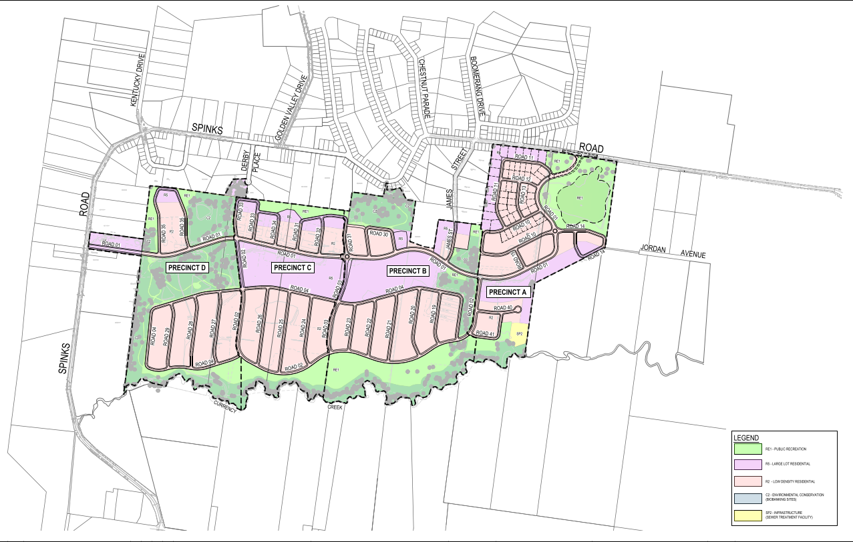
Figure 1. Concept Masterplan under DA0266/23

2.6 Lake Health Package Approval
DA0343/23 was approved by Council on the 11th of July 2024. The proposal sought the construction of a lake wetland system consistent with the approved concept masterplan. The civil works included earthworks to facilitate the lake and surrounding infrastructure, construction of shared pathways, footpaths & a bridge and vehicular access tracks. It is noted that the delivery of the lake embellishment is under separate approval under DA0419/23
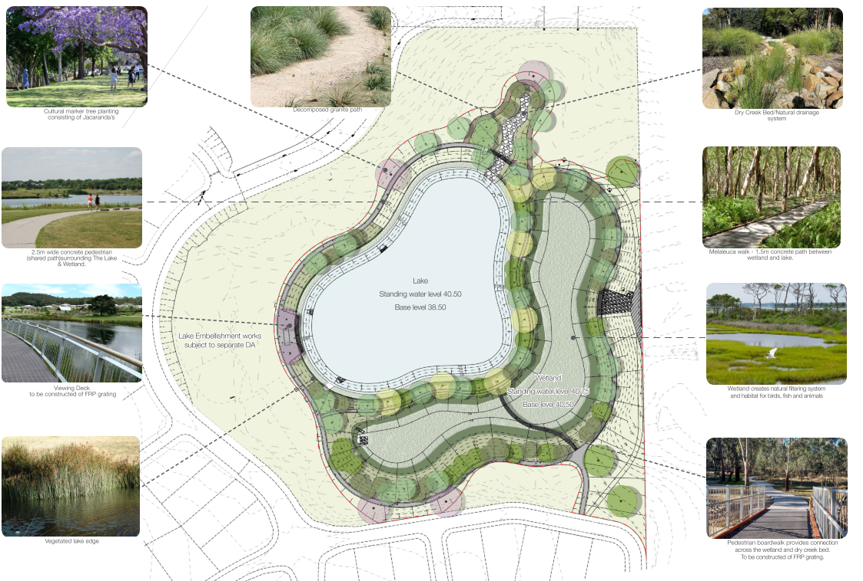
Figure 2. Approved lake package.

3. Site Description & Conditions

The Jacaranda Release Area

The subject site consists of nine (9) properties and has an area of approximately 185.3ha as shown in Table 1.

Lot/DP | Lot size
Lot 201 DP1268299 | 15.69ha
Lot 202 DP1268299 | 29.05ha
Lot 203 DP1268299 | 24.82ha
Lot 204 DP1268299 | 28.39ha
Lot 205 DP1268299 | 23.82ha
Lot 206 DP1268299 | 26ha
Lot 207 DP1268299 | 34.89ha
Lot 208 DP1268299 | 4,081m²
Lot 209 DP1268299 | 6,953m²
Lot 210 DP1268299 | 2.023ha

Table 1. Existing Lot Sizes

The subject development site is irregular shape and currently contains a free range egg production farm consisting of 10 sheds within the north-western part of the subject site, a chicken rearing farm consisting of 24 sheds within south-western part of the subject site. A total of eight (8) dwellings and ancillary farm buildings are located throughout the site and the remainder is cleared and undeveloped with patchy tree coverage. The development site also contains eight dams, significant vegetation and endangered habitat, but the majority of the subject site is cleared and undeveloped.

The land is undulating and varies in elevation from approximately 80m AHD westerly, 70m AHD northerly, 40m AHD easterly, and 30m AHD southerly, and contains a ridgeline running east -west through the northern part of the subject site.

Currency Creek which forms the southern boundary of the subject site and bounded by a riparian vegetation corridor provides habitat for riparian fauna and holds aquatic fauna. Three unnamed watercourses which are tributaries of Howes Creek run from north to south at the northern boundary.

Topographically, a central ridge line runs through the property splitting flow paths to the north of the site and south towards Currency Creek. Grades transition from 12% towards this ridge and tapers off towards shallower grades of 1-3% around Currency Creek.

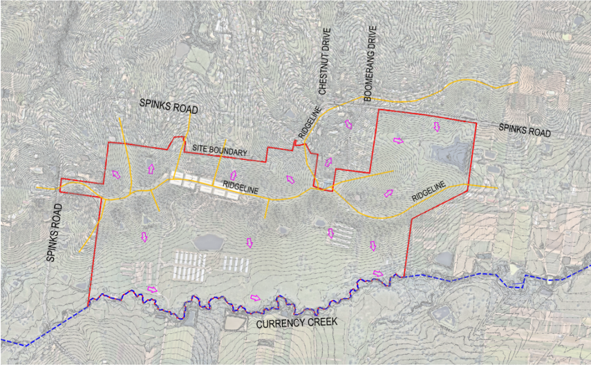
Figure 2. Topographical map. Source: Enspire Solutions

As illustrated in Figure 3 below, the subject site is bounded by Spinks Road and low-density residential land to the north, Currency Creek to the south, primary production/rural agricultural land to the east and Spinks Road and primary production/rural agricultural land to the west.

The subject site is located immediately adjoining the existing Glossodia village which is the second largest residential community north of the Hawkesbury River within the Hawkesbury Local Government Area (LGA) behind North Richmond.

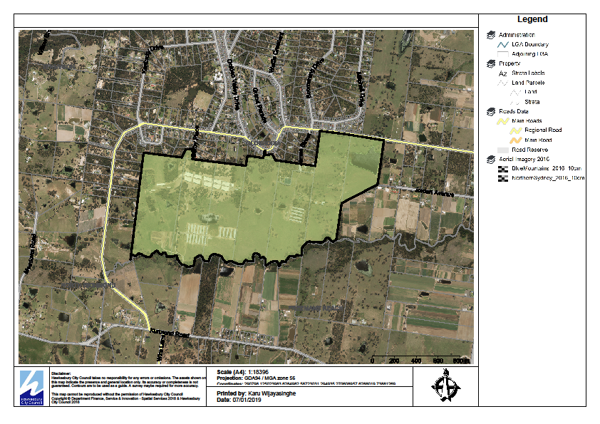
Spinks Road
Glossodia Residential
Community

Glossodia
Neighbourhood Centre

Primary production/rural agricultural land
Low density
residential

Public open space
Glossodia Public School
Primary production/rural agricultural land
Primary production/rural agricultural land
Primary production/rural agricultural land
Subject Site

Figure 3. Subject Site and Surrounds

As shown in Figure 3 above, the subject is surrounded by a mix of land uses including residential, primary production/rural agricultural land uses, public open spaces, schools and retail uses. North of the subject site beyond Spinks Road is predominantly low density residential. Figure 3 also shows that the subject site is located within a reasonable walking distance (approximately 700m) to the existing Glossodia village.

Public transport routes can be found at Windsor Railway Station, approximately 9km from the site and Richmond Railway Station which is 6km away from the subject site. Both rail stations are located on the T1 & T5 lines connecting greater Windsor with the Sydney CBD. Further, bus stops are located along Spinks Road, facilitating the 668 Bus route (Windsor to Richmond via Wilberforce, Glossodia & North Richmond).
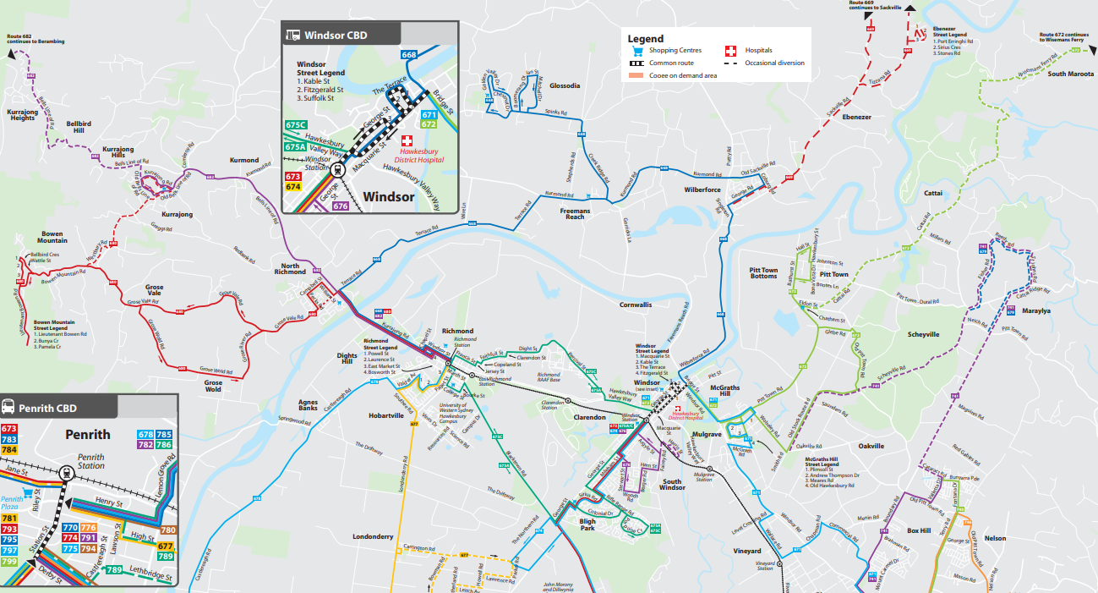
Figure 4. Bus routes in Greater Windsor.

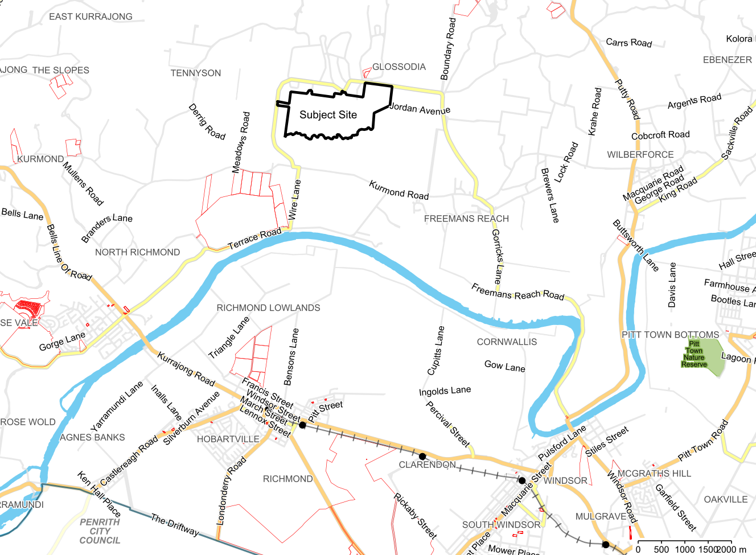
Figure 5. Greater Locality Map

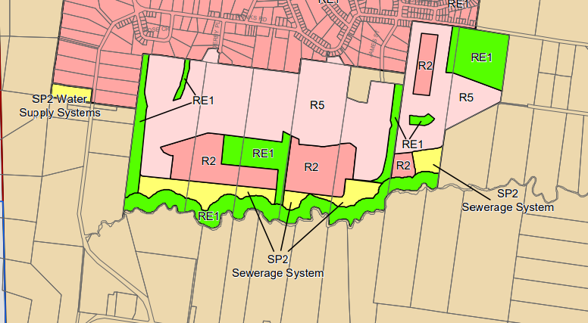
Figure 6. 2014 LEP Amendment

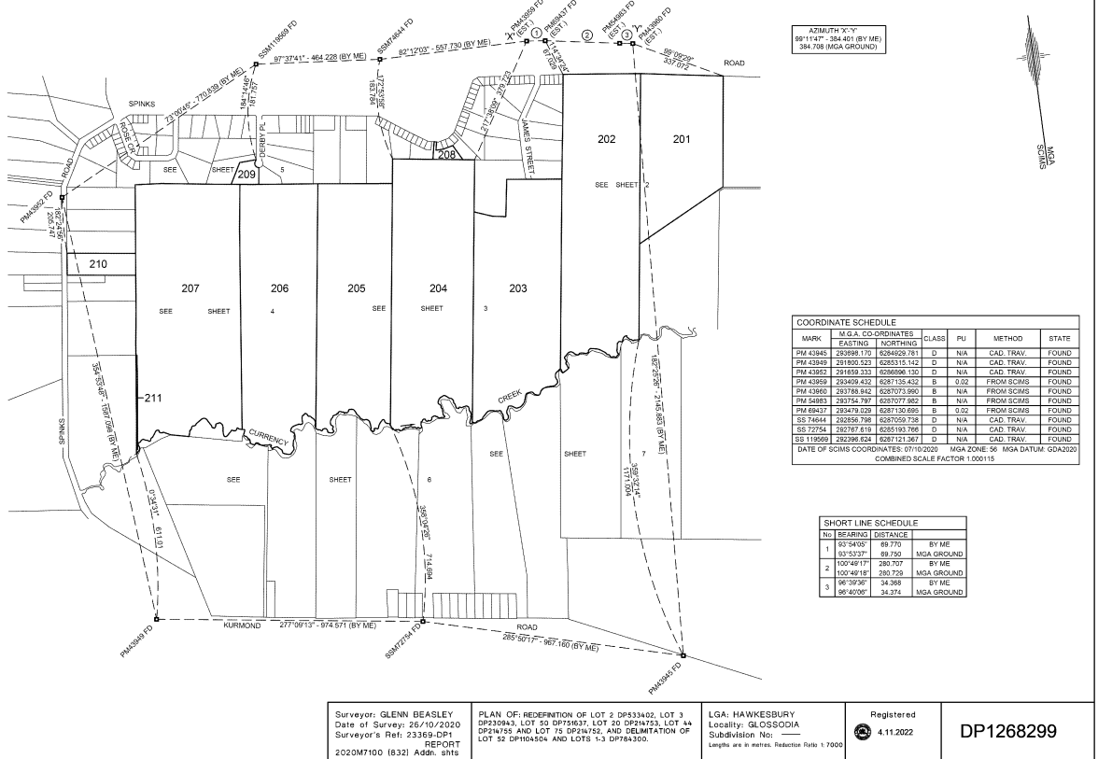
Figure 7. Deposited Plan 1268299
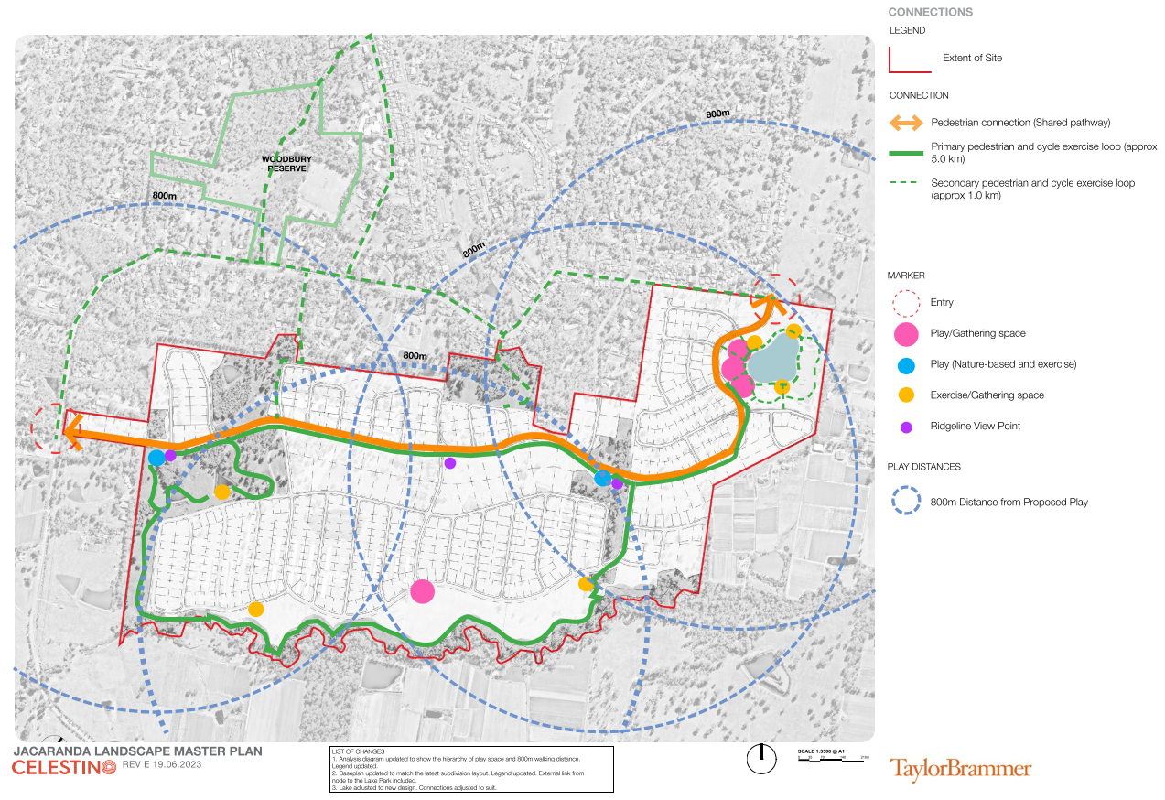
Figure 8. Walkability and Open space map. Source: Taylor Brammer

The Pace Development Site

The PACE land encapsulates precincts C & D of the Jacaranda release (Lots 207, 206 & 205 DP 1268299). As shown below under Figures 9 and 10, the proposed subdivision layout is entirely consistent with the approved Concept Masterplan. Lots produced under the subject application result in 256 new Torrens Title allotments of which, is in keeping with the allowable 580 total lots to the whole precinct.

Lot Reference under DP 1268299 | Address | Area
205 | 7890A-780C Kurmond Road, Glossodia | 23.824085 Hectares
206 |  | 26.014936 Hectares
207 |  | 35.138876 Hectares
210 | 361 Spinks Road, Glossodia | 2.025647 Hectares
As the Jacaranda release is sought to be developed and delivered by two separate entities/developers, it is taken that a final stage of development between precincts C & B will be delivered by both Celestino and PACE in order to identify and deliver the remainder of lot credits to reach the approved 580-lot release. Under this arrangement the following residential lots are currently under assessment:

DA Reference | Lots Produced | Developer | Status
DA0508/23 | Sixty-Four (64) | Celestino | Under assessment
DA0312/24 | Fifty-Two (52) | Celestino | Under assessment
DA0409/24 | Two Hundred & Fifty-Six (256) | PACE | Subject application
Total Lots to date | Three Hundred & Seventy-Two (372) | Celestino – 116  PACE – 256

Precinct | Indicative Yield | Maximum Yield
A | 150-160 | 300
B | 140-150
C | 155-165 | 280
D | 115-125
Table X. Indicative Lot Yield per Concept Masterplan
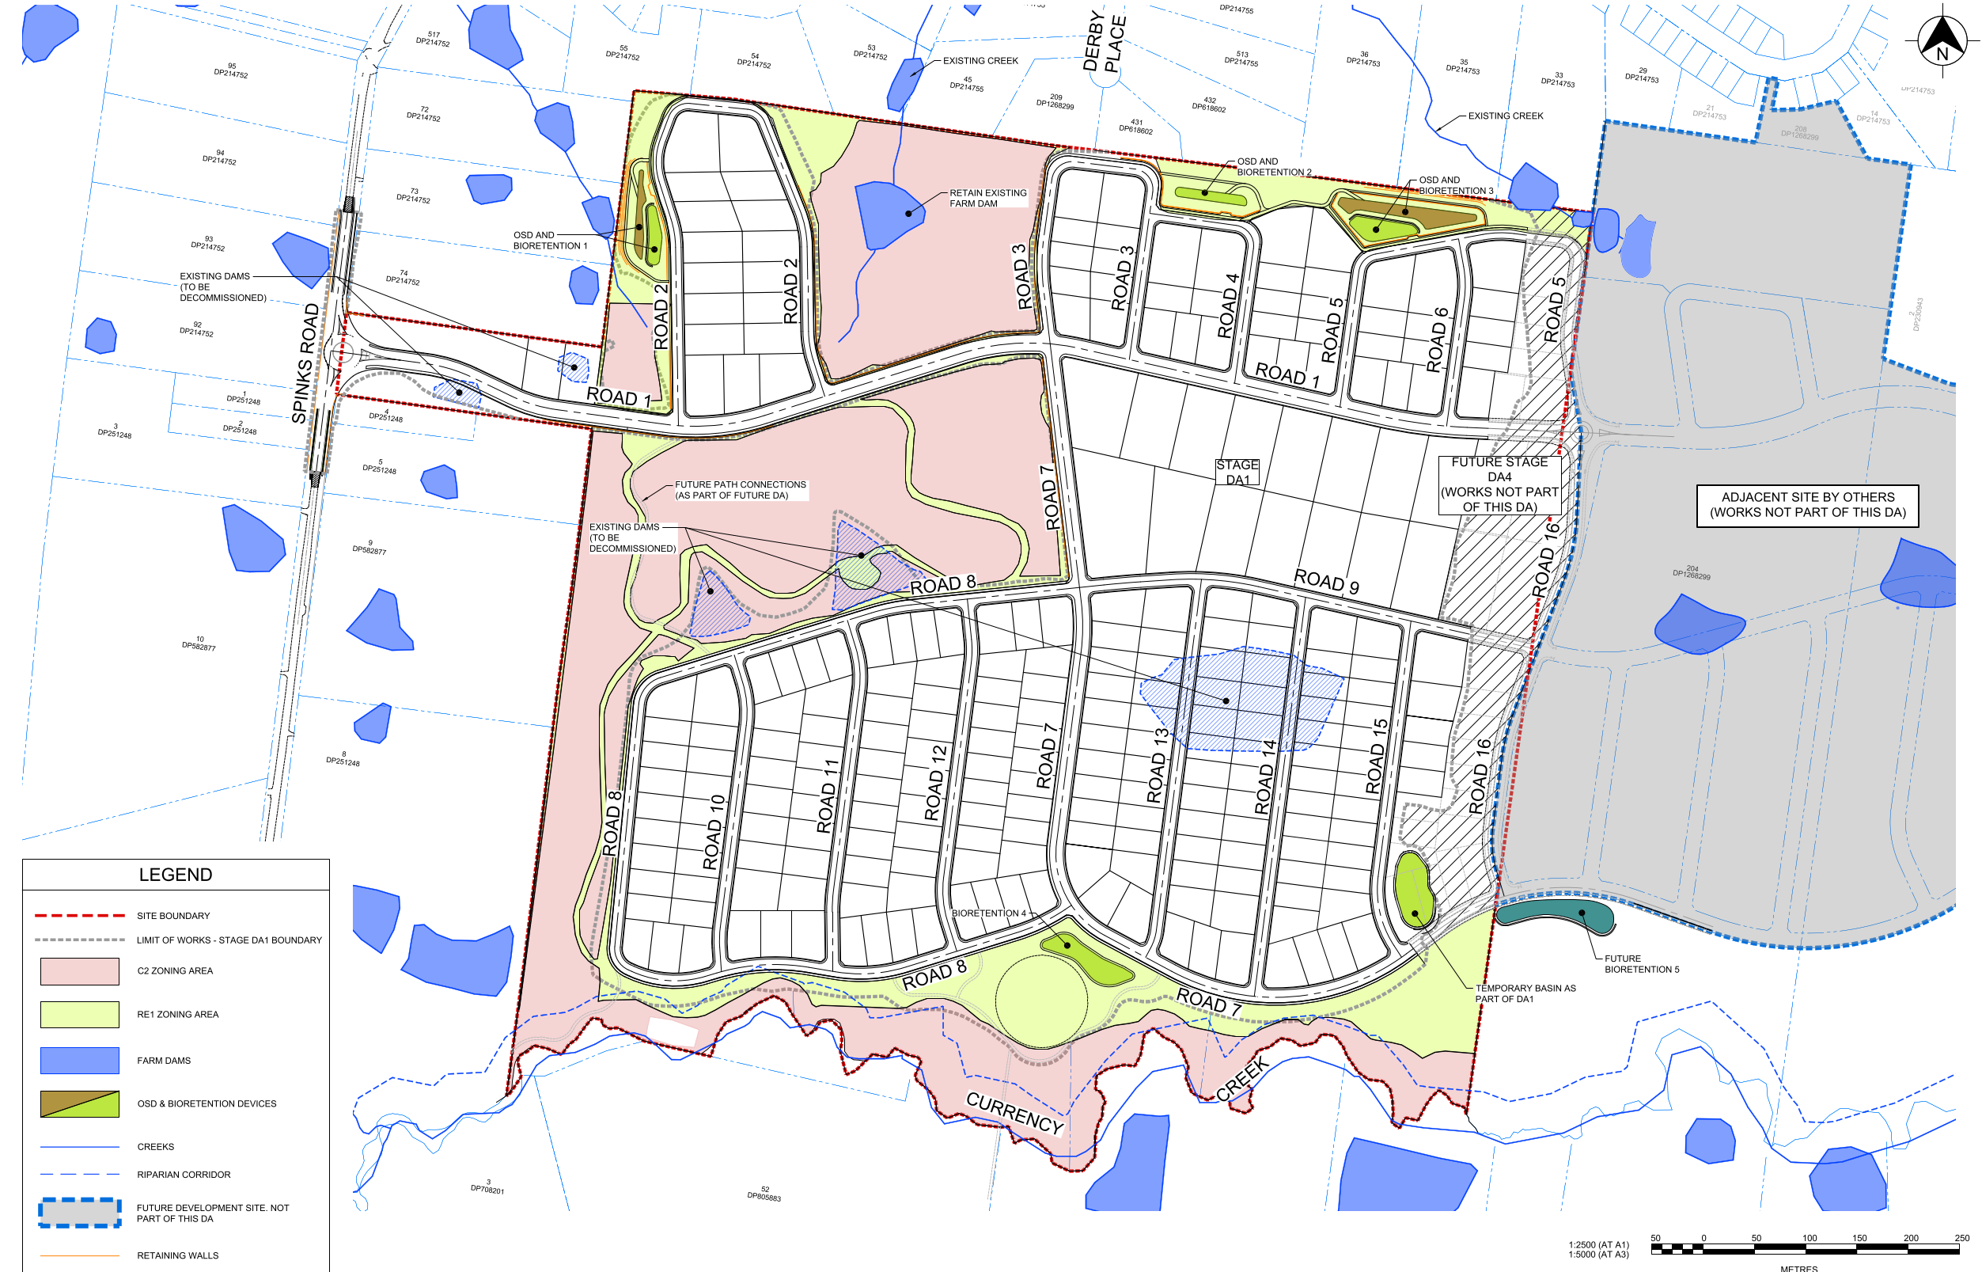Figure 9. PACE general proposed site layout.

4. Proposed Development

Works already endorsed under the Concept Masterplan

The following works have already been endorsed under stage 1 of the Concept Development Application (DA0266/23) and therefore are not sought under this approval package.

4.1. Remediation

The Remediation Action Plan (RAP) for stages C & D was approved as part of the Concept Masterplan Approval and applies to the site. No changes to the approved RAP is sought under this application and a condition of consent will be imposed for the completion of remediation works prior to the issuance of a Subdivision Certificate.

4.2. Demolition

Demolition plans were endorsed under the Concept Development Application under DA0266/23 in which applies to the site. No changes are sought to the approved demolition plans and the submitted civil engineering plans provide detailed design of the clearing works.

4.3 Dam Dewatering

A dam dewatering plan for stages C & D were endorsed as part of the Concept Development Application. No changes are sought to the approved demolition plans and the submitted civil engineering plans provide detailed design of the dam dewatering works.

Works proposed under the Subject Application

4.4. Staged Subdivision and delivery of 256 Torrens Title Allotments.

Staged subdivision of Lots 205, 206 and 207 DP 1268299 to create 256 Torrens Title Subdivision with allotments ranging from a minimum lot size of 1,014m² to 5,662m².

The proposed staging delivery are proposed as follows:
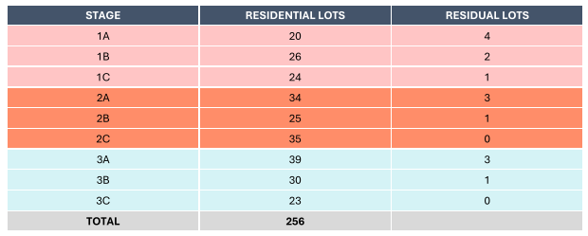

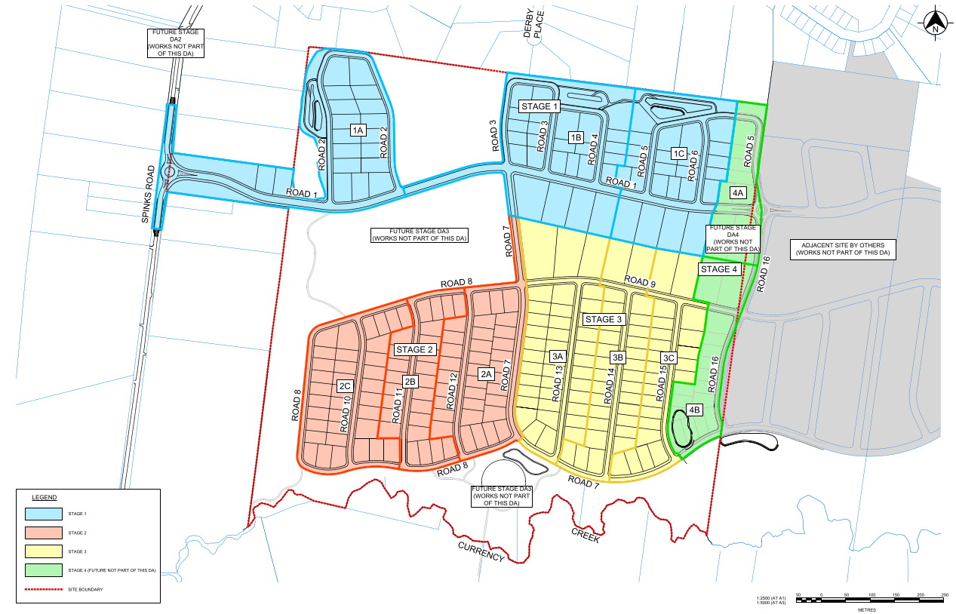
Figure 10. PACE Jacaranda Delivery & Staging Plan.

4.5. Earthworks

A bulk earthworks design was approved under Stage 1 of the Concept Development Application. The subject application seeks to further refine the land levels in accordance with the detailed design being delivered for road works and the proposed subdivision layout.

The updated earthworks demonstrates that a total of 180,000m³ of fill is required, which is a reduction of 40% in comparison to the approved bulk earthwork design under the concept approval.

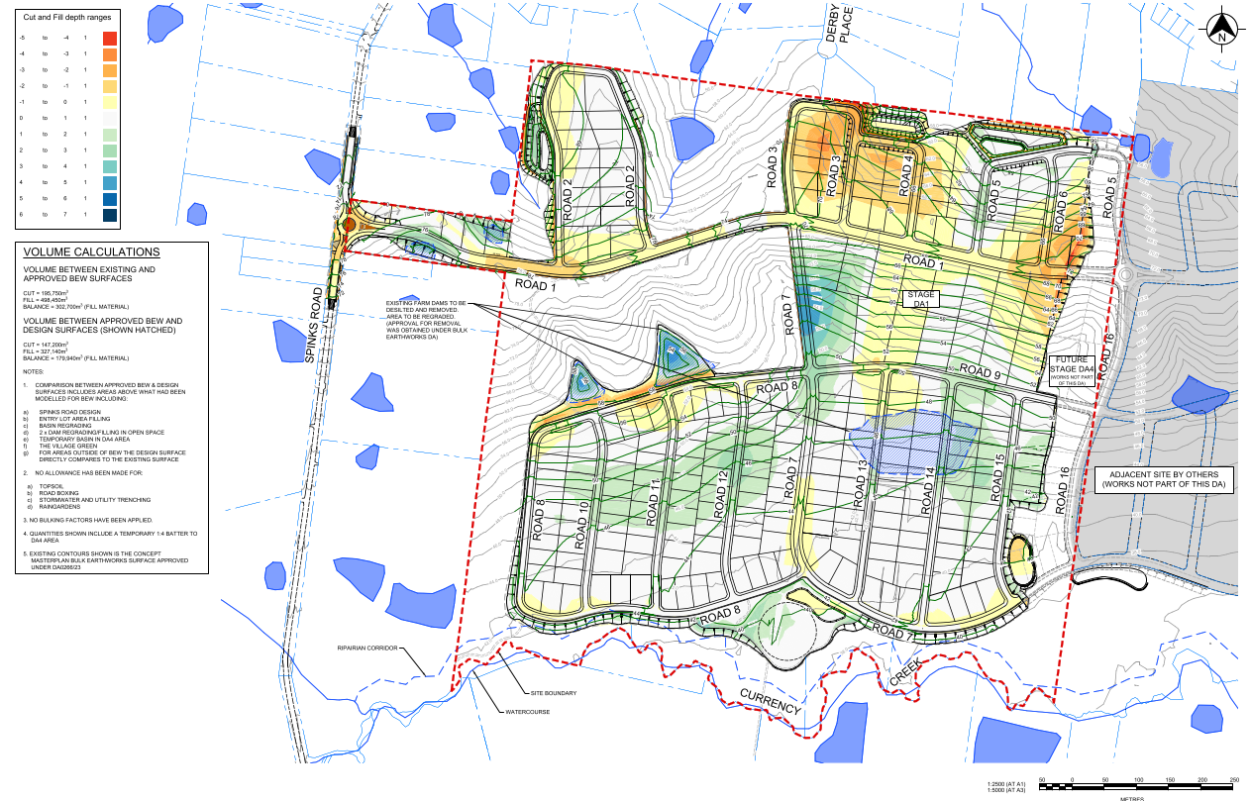
Figure 11. Proposed Cut & Fill Plan

4.6 Roadworks

The proposed road layout is entirely consistent with the endorsed Concept Masterplan layout.

It is noted that the length of Road 1 (shown in dark blue under figure 12 & referenced under figure 13), contains a shared pedestrian/cycle pathway. Consistent with Figure 8 of the Hawkesbury Development Control Plan 2002, Part E, Chapter 9 Jacaranda - Glossodia special character area.

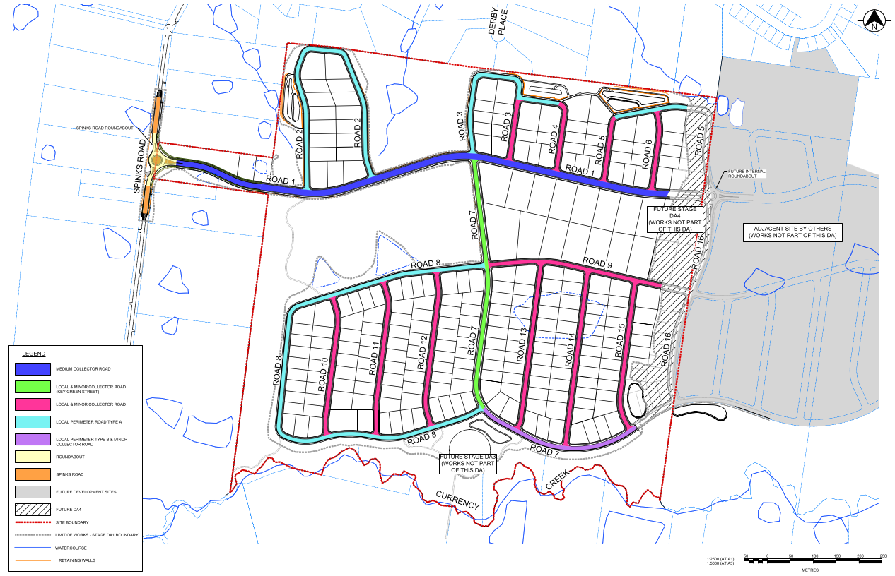
Figure 12. Proposed Road Hierarchy & Layout.

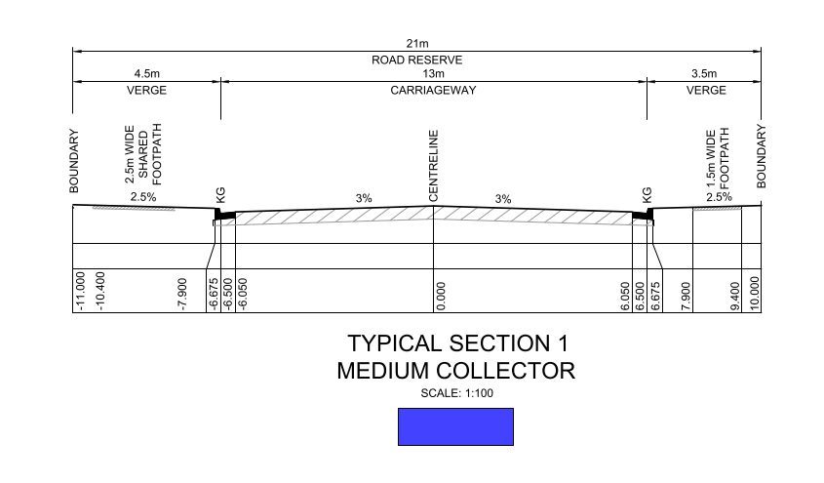
Figure 13. Road 1 cross-section denoting 13m carriageway and 1.5/2.5m pedestrian/shared pedestrian footpath.

4.7 Spinks Road (West) intersection treatment

Condition No.19 of the approved concept masterplan reads as follows:

“Provision of road intersection treatment at the western end of intersection of Spinks Road/Road No.1 is to be confirmed prior to the submission of any development applications related to subdivision works on precinct D.

Note: Councils' preference is that a roundabout be provided to this interface, however alternative option for equivalent measures may be considered with suitable justification.”

It is noted that several meetings were held prior to the lodgement of the subject Development Application confirming the intention of providing a suitable roundabout compliant with Council’s design criteria. The separate application provides a roundabout intersection long the western interface of Spinks Road leading into the western part of the Jacaranda release. The roundabout has been designed along with input from Council’s Engineering and Design team along with advice from Transport for NSW. Notwithstanding, a condition of consent has been imposed for the submission of intersection documents to the Local Traffic Committee for review.

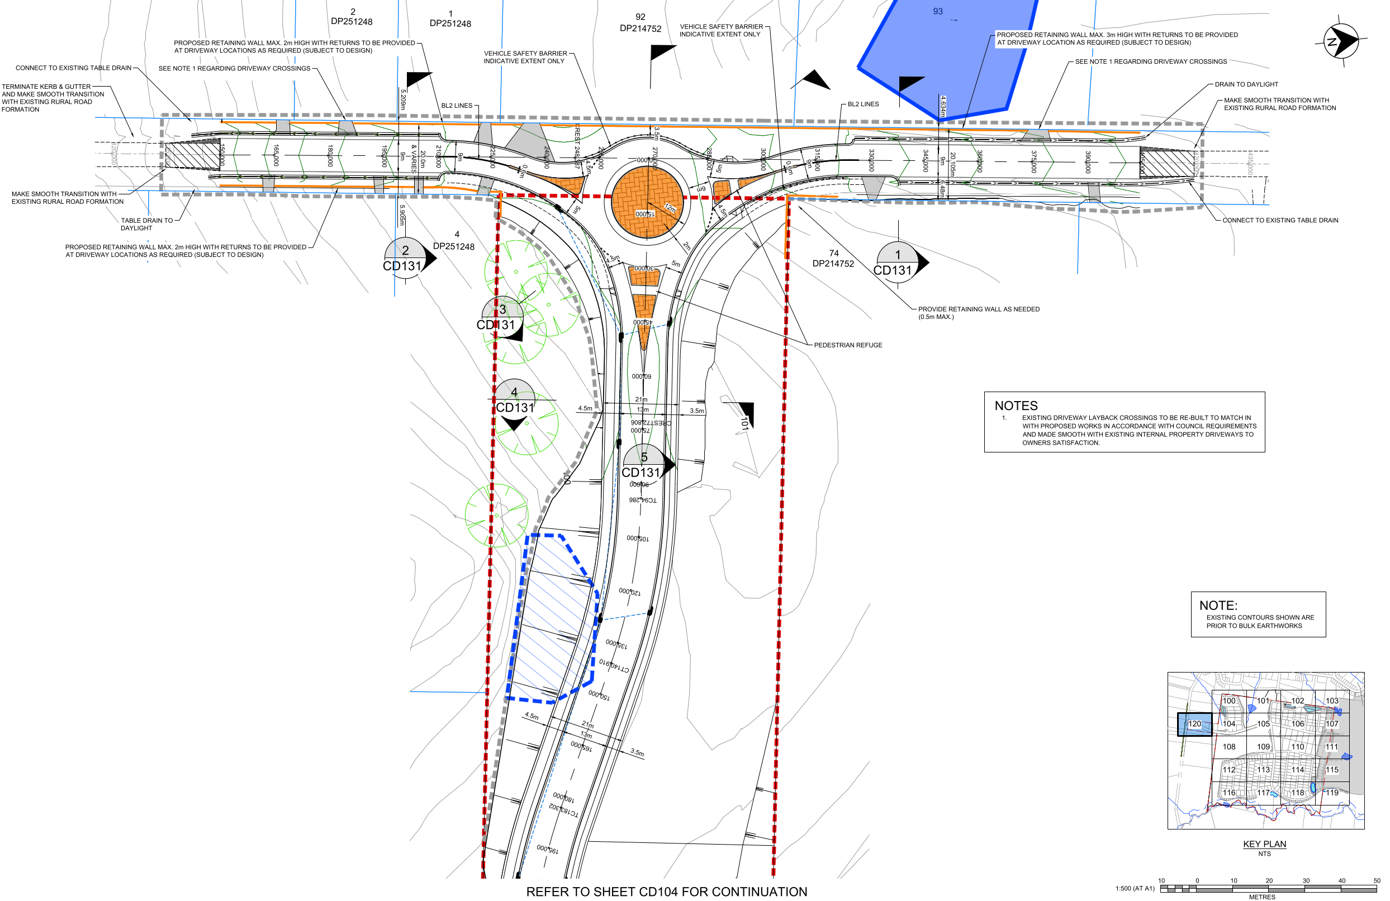
Figure 14. Roundabout Civil Design

4.8 Landscaping

The proposed development seeks the landscaping of the general streetscape and trafficable areas. It is noted that the open spaces are sought to be embellished and delivered under a separate Development Application.

Refer to below Figure 14 for full landscape embellishment works along roads being delivered under this application.

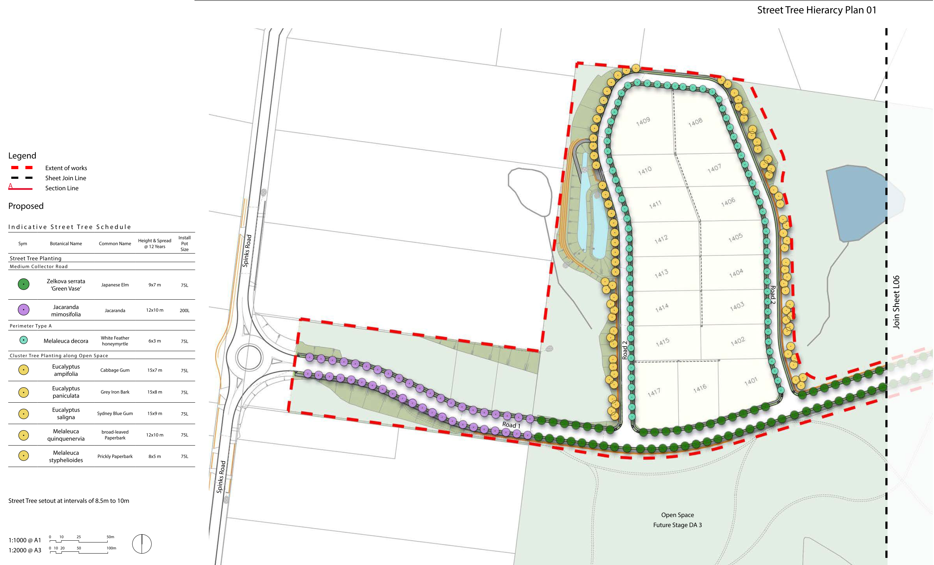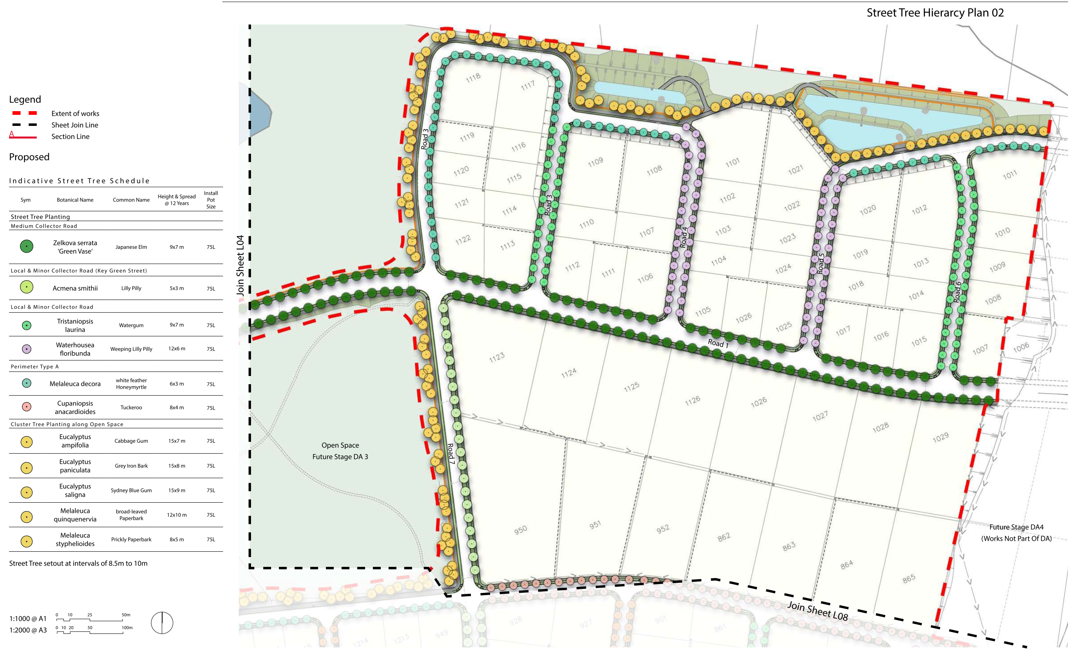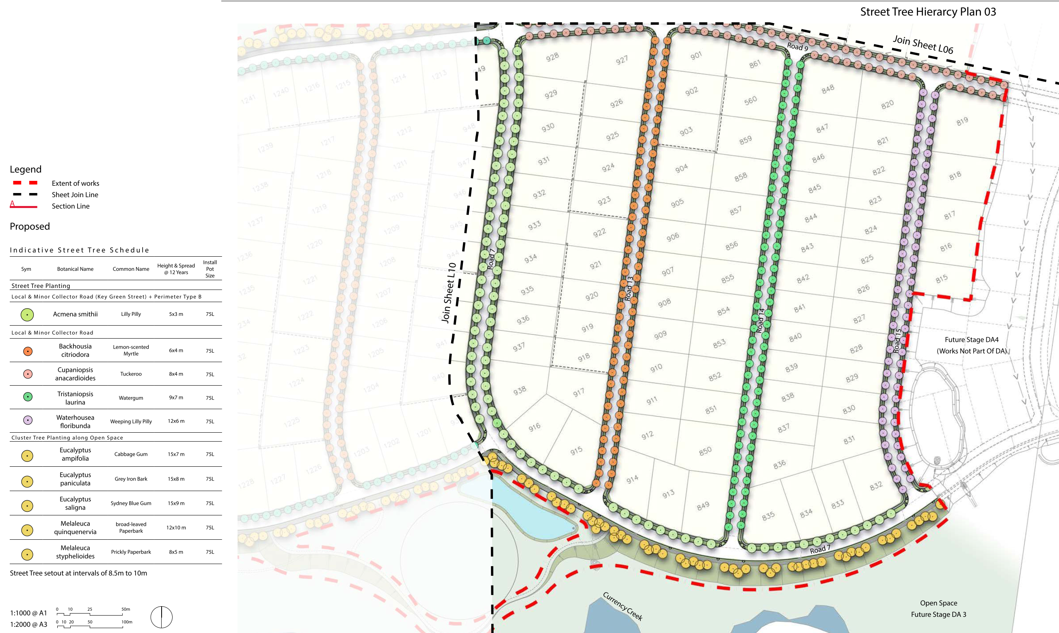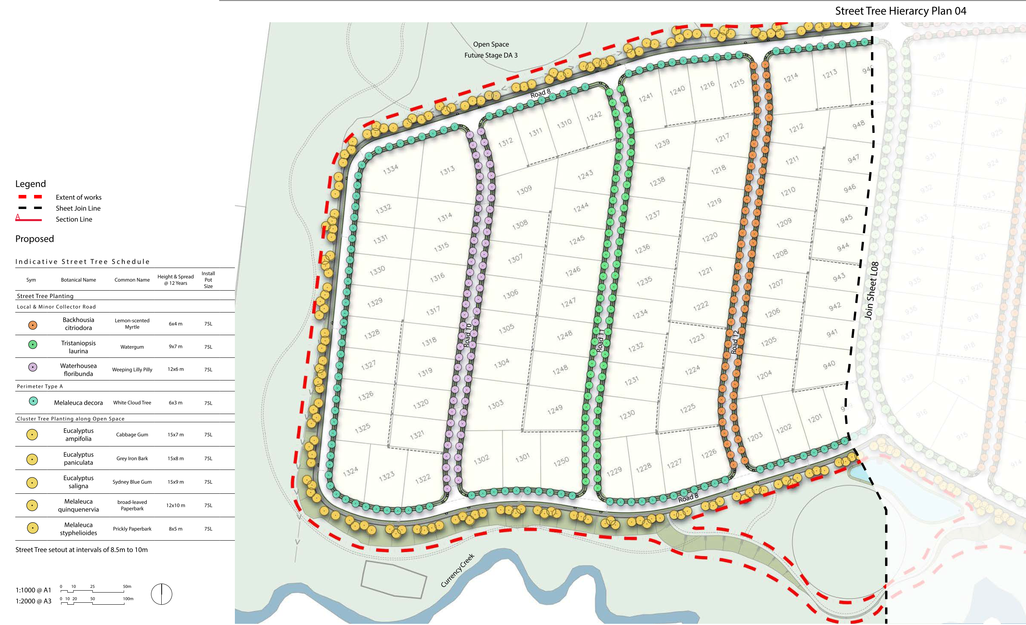
Figure 15. Streetscape landscape plans

4.9 Utility Services

4.9.1 Water supply

The proposed development would be serviced by a supply of potable water from Sydney Water with a connection to the existing 450mm potable water main along Spinks Road being sought. Internal reticulation system pipes with widths of 100mm and 250mm will be delivered in a staged manner in accordance with the delivery of residential lots.

4.9.2 Sewer and Recycled Water

In accordance with the endorsed concept approval, the management of wastewater would be serviced by Altogether Group within the Local Water Centre located southeast of the Jacaranda release. A Water Industry Competition Act 2006 (WICA) license has been issued (13_001R) and the facility inclusive of sewage and recycled water systems will be delivered under the SP2 Sewerage System zone under a Part 5, Review of Environmental Factors application separates to the current Development Application.

It is sought that a pressure sewer and recycled water connection be provided to connect Precincts C & D to the scheme once completed. As an interim measure until the treatment plant is completed and operational, pump out trucks may be used to service the development.

4.9.3 Communications

Telecommunication services are sought to be delivered by the National Broadband Network via a NBN pit and pipe networks at the frontage of 361 Spinks Road. Telecommunication services are to be delivered as part of the first Stage (1A) of the development. PACE has advised Council that a Master Developer Agreement with the NBN Co has been formally entered into.

4.10 Stormwater Management Works

The submitted hydrologic analysis prepared by JWP denotes that three (3) detention basins with active storage volumes of 3,000m³ (B1), 2,500m³ (B2) & 7,500m² (B3) are required to ensure that the flow paths resultant post development are equal to or no less than pre-existing flow conditions in events leading up to and including the 1% annual exceedance probability (AEP) downstream of the development area. It was also confirmed that as part of the deliver of stage one (1) to three (3) under this consent, no additional basins would be required.

The strategy provides water quality treatment systems inclusive of rainwater tanks, gross pollutant traps and bioretention raingarden filter media to meet stormwater quality targets. The provided bioretention raingarden filter media area is 5,700m² and meets the Hawkesbury City Council targets for water quality.

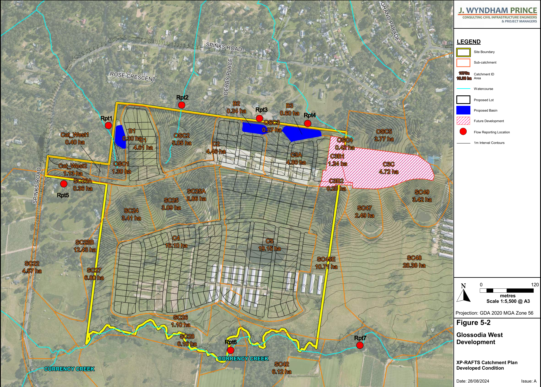
Figure 15. Proposed Stormwater Catchment Details

4.11 Erosion & Sediment Control

The bulk of sediment and erosion measures were endorsed as part of the bulk earthworks stage under the concept approval. Notwithstanding, measures to prevent sediment and erosion run off are detailed as follows:

- Installation of a temporary site security/safety fence.
- Stabilisation of construction access points.
- Installation of sediment fencing downstream of disturbed areas (including topsoil stockpiles).
- Construction of temporary sediment basins.
- Installation of inlet filters around stormwater inlets.
- Implementation of dust control measures such as covering stockpiles, installing fence hessian, and watering exposed areas.

All stockpiles including topsoil will be located away from nearby watercourses and temporary overland flow paths with sediment fences located on downstream sides of stockpiles and embankment foundations.
5. Application History

Date | Comment
15/08/2024 | Application lodged on the NSW Planning Portal.
28/08/2024 – 25/11/2024 | Application placed on public advertising
16/10/2024 | Concurrence approved by Endeavour Energy
25/10/2024 | Additional information request raised by Department of Planning Water
28/10/2024 | Additional information requested from Council
01/11/2024 | Concurrence approved by TfNSW
25/11/2024 | Briefing held with the Sydney Western City Planning Panel
20/02/2025 | General terms of approval provided by the Rural Fire Services
11/02/2025 | Additional information response provided to Water NSW
28/02/2025 | Meeting held with applicant & Council to discuss RFI
07/03/2025 | Meeting held with applicant & Council to discuss RFI
18/03/2025 | Additional information provided to Council
26/03/2025 | Meeting held with applicant & Council to debrief submission of RFI
02/05/2025 | Draft Conditions of consent provided to applicant for review

6. Referrals

Stakeholder | Comment
Parks | Supported subject to the imposition of conditions.  Note:  The Parks team initially raised an additional information request with regard to the tree species used and materials used for the access track among other minor changes to the submitted plans.  Additional information was provided on the 15 January 2025, to which Council’s Parks officer noted as supportable.
Engineering | Supported subject to the imposition of conditions.  Note:  Council’s Engineers have reviewed the submitted civil plans inclusive of intersection treatment and conditions of consent have been provided.
Assets | Supported subject to the imposition of conditions  Note:  Council’s Assets team provided comment on the proposed roundabout and pavement design for pedestrian and shared pedestrian pathways to the Jacaranda Precinct.
External Referrals
Rural Fire Service | General terms of approval issued
Department of Planning - Water | A referral was provided to the Department of Planning Water on the 11 October 2024. An additional information request was raised on the 25 October 2024. Additional information was provided on the 11 January 2025. No response from the Department was received in response.  Notwithstanding, general terms of approval were provided under DA0266/23 in which a Controlled Activity Approval would be required prior to works on waterfront land.  The terms of the GTA under DA0266/23 note that the prescribed controlled activity must be in associated to the plans and denoted in schedule 1 replicated below.  Schedule 1:  - Statement of Environmental Effects, Ref. 11918, prepared by GLN, dated 30/06/2023  - Demolition and Concept Civil Engineering Plans, Ref. 190087-06, prepared by Enspire Solutions pty Ltd, Rev. 2, dated 29/08/2023  - Aboriginal Cultural Heritage Assessment, Ref. 1749, prepared by Kellher Nightingale Consulting pty Ltd, dated December 2022  - Flora and Fauna Assessment, Ref. 190087-06, prepared by Ecological Australia, Ver 6, dated 06/02/2023  - Asset Protection Zone Plan, prepared by Peterson Bushfire, undated  - Remedial Action Plans for each Stage, prepared by JBS & G, dated 16/12/2022  - Currency Creek Riparian Works Plan, Dwg. SK0201-190087-00, prepared by Enspire Solutions Pty Ltd, Rev. 1, dated 17/11/2023  It is noted that the proposed development is made pursuant to Section 4.22 of the Environmental Planning and Assessment Act 1979 and form stage 2 of the concept approval concept approval. As such, the contents of this application are entirely consistent with the approved concept masterplan.  As such, it is taken that notwithstanding the lack of response from the Department of Planning – Water, amended General Terms of Approval are not required in this instance.
Transport for NSW | No issues raised with the proposed development.  Note: TfNSW provided an initial review and conditions with respect to a Green Travel Plan prior to the issue of the first residential subdivision certificate at the Jacaranda Precinct.

7. Environmental Planning Instruments

7.1 Overview

The instruments applicable to this application are:

- Environmental Planning and Assessment Act 1979;
- Environmental Planning and Assessment Regulations 2021;
- Biodiversity Conservation Act 2016;
- Environmental Protection and Biodiversity Conservation Act 1999;
- National Parks and Wildlife Act 1974;
- State Environmental Planning Policy – (Biodiversity & Conservation) 2021 ;
- State Environmental Planning Policy (Resilience & Hazards) 2021;
- State Environmental Planning Policy (Transport & Infrastructure) 2021;
- Hawkesbury Local Environmental Plan 2012 (LEP 2012);
- Hawkesbury Development Control Plan 2002 (HDCP 2002); and
- Hawkesbury Council Flood Policy 2020

7.2 Environmental Planning and Assessment Act 1979

7.2.1 Designated Development
Pursuant to Section 4.10 of the Environmental Planning and Assessment Act 1979, an application can be identified as ‘Designated Development’ under the Environmental Planning and Assessment Regulations 2021 (the regulations) or any other such environmental planning instrument.

Under Clause 45 of Part 2, Schedule 3 of the Environmental Planning and Assessment Regulation 2021, Waste Management Facilities or Works is noted as follows:

“Waste management facilities or works that store, treat, purify, or dispose of waste or sort, process, recycle, recover, use or reuse material from waste and comprise more than 100,000 tonnes of 'clean fill' that is likely to cause significant impacts on drainage or flooding are characterised as designated development.

Waste management facilities or works that are in or within 100 metres of a natural waterbody, or within 500 metres of a residential zone that are likely to significantly affect the amenity of the neighbourhood can also be characterised as designated development.

The proposed earthwork refinement works sought under subdivision stage one (1) to three (3) of the proposed development would seek to utilise material onsite that could potentially be characterised as ‘waste management works’ with 100m of a natural waterbody with the scale also exceeding 100,000 tonnes.

As noted in Section 4.5 of this report, the proposed earthworks are a reduction of the approved bulk earthworks endorsed under the concept approval. Notwithstanding, it is taken that these earthworks are incidental in delivering consistent contours for the Jacaranda precinct.

It can be considered that the intent of Clause 45 of Schedule 1 of the Regulations remains to ascertain risk of “Waste management facilities or works” as defined below:

“Waste management facility or works means a facility or works that—
(a) stores, treats, purifies or disposes of waste, or
(b) sorts, processes, recycles, recovers, uses or reuses material from waste.”

Further, Waste is defined under part 1 of schedule 3.

“(2) In this Schedule, waste includes a matter or thing that—
(a) is solid, gaseous or liquid or a combination of solid, gaseous or liquid, and
(b) is discarded or is refuse from processes or uses.
Example — Domestic, medical, industrial, mining, agricultural or commercial processes and uses.

(3) A substance may be waste for the purposes of this Schedule even if it may be—
(a) reprocessed, re-used or recycled, or
(b) sold or intended for sale.”

Council is of the view that the site to be recontoured as part of the detailed proposal do not meet the definition of waste as it cannot be described as material discarded or refused from processes or uses.

In this respect, Council does not consider the concept proposal is not applicable to Designated Development.

7.2.2 Concept Development Applications
The application is made pursuant to Section 4.22 of the Environmental Planning and Assessment Act 1979.

The concept development application was approved on the 15 December 2023 by the Sydney Western City Regional Planning Panel. This subject application continues with to the delivery of the Jacaranda masterplan in which two hundred and fifty-six (256) residential lots are sought across Precincts C & D.

7.3 Biodiversity Conservation Act 2016
Section 1.7 of the Environmental Planning and Assessment Act 1979 requires consideration as to whether a proposed development will have a significant effect on threatened species, populations or ecological communities relating to terrestrial and/or aquatic environments under the Biodiversity Conservation Act 2016.

On 25 August 2017, the Biodiversity Conservation Act 2016 commenced, superseding the Threatened Species Conservation Act 1995 (TSC Act).

On 21 November 2017, the Minister for the Environment made the Proposed Applications for Biodiversity Certification Order 2017 (the Order) pursuant to Clause 37(2) of the Biodiversity Conservation (Savings and Transitional) Regulation 2017. The Order provided that for nominated sites, an application for Biodiversity Certification may be made for assessment under Part 7AA of the TSC Act (in lieu of the new BC Act provisions) if lodged by 25 August 2019. Clause 4(7) of the Order names the Jacaranda site, and the Biodiversity Certification application was lodged prior to this date.

The Biodiversity Certification Order for Jacaranda was published in the NSW Government Gazette on 20 August 2021. As required by the Order, a Biodiversity Certification Agreement was later executed by Council and the Applicant.

Clause 37 of the Biodiversity Conservation (Savings & Transitional) Regulation 2017 states that biodiversity certification conferred on land under the TSC Act is taken to be Biodiversity Certification conferred on the land under Part 8 of the BC Act.

The area of Biodiversity Certified land under the Biodiversity Certification Agreement is illustrated within Figure 19. Vegetation clearing is confined to R2 and R5 zoned land that is ‘Biodiversity Certified’ consistent with the BCA and does not require further assessment of the impacts to biodiversity.

The proposed development seeks the removal of vegetation on biodiversity certified land. As such no further assessment is required for the tree removal on these spaces in this regard.

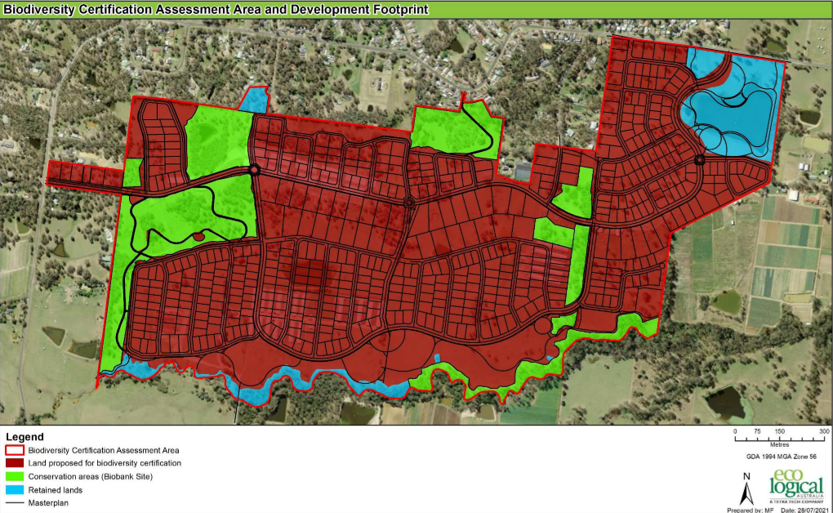
Figure 19. Land use map. Source. EcoLogical.

7.4 Environmental Protection and Biodiversity Conservation Act 1999

Approval under the Commonwealth Environmental Protection and Biodiversity Conservation Act 1999 (EPBC Act) was granted by the Federal Government on 17 June 2020 for the whole of the Jacaranda development.

The EPBC Act is currently undergoing review however the approval has effect until 19 June 2040 and means that no further assessment under this Act is required. All Credits required to have been retired have been imposed under the concept approval DA0266/23.

The proposed tree removal as part of this subject application is entirely within Biodiversity Certified Lands and are consistent with the Approval under the EPBC Act.

7.5 National Parks and Wildlife Act 1974
The purpose of the National Parks and Wildlife Act 1974 (NP&W Act) is to conserve NSW's natural and cultural heritage, as well as foster public appreciation, understanding and enjoyment of NSW's natural and cultural heritage, and managing any lands reserved for the purposes of conserving and fostering public appreciation and enjoyment of NSW's natural and/or cultural heritage. It is also the principal legislative instrument for the protection and management of Aboriginal cultural heritage places and objects in NSW.

The applicant reviewed the Aboriginal Heritage Information Management System (AHIMS) Register and identified one (1) Aboriginal site (45-5-3794) recorded within Precinct D in containing a single artefact under the approved Concept Masterplan.

A Heritage Impact Statement was prepared by GML Heritage in 2018 to inform the Planning Proposal and was the precursor to the Aboriginal Cultural Heritage Assessment prepared by Kelleher Nightingale in 2020. The Statement broadly categorised the subject development site as having low/nil significance except for two Potential Archaeological Deposits (PAD) and the identified site.

This application proposes remediation and earthworks that will impact PAD's and both sites. As such, this application has been identified as Integrated Development and an Aboriginal Heritage Impact Permit (AHIP) under the NP&W Act will be required.

The Concept Development Application was identified as integrated development and referred to Heritage NSW under Section 90 of the National Parks and Wildlife Act 1974. It is noted that on the 14 November 2023, Heritage NSW provided their general terms of approval in response.

As part of Concept Development Application an Aboriginal Heritage Impact Permit (AHIP) (AHIP 5241) was issued for the collection and salvage for the entirety of the Jacaranda Masterplan Area. The actions authorised under this AHIP was completed and confirmed by Kelleher Nightingale Consulting, with all conditions related to the excavation and collection of Aboriginal objects within the AHIP boundary being satisfactorily completed & no additional mitigation works required.

It is therefore taken that no further assessment nor referral to Heritage NSW is required.

7.6 Rural Fires Act 1997
Section 100B of the Rural Fires Act 1997 requires that a bush fire safety authority for a subdivision of bush fire prone land that could lawfully be used for residential or rural residential purposes, or development of bush fire prone land for any 'special fire protection purpose'.

The subject site is mapped as bushfire prone land and is sought to be released as residential land. The application was referred to Rural Fire Service seeking seeks General Terms of Approval to which on the 20 February 2025, the RFS provided their general terms of approval.

7.7 State Environmental Planning Policy (Biodiversity and Conservation) 2021.

7.7.1 Chapter 4 – Koala Habitat Protection 2021.

Chapter 4 of the State Environmental Planning Policy (Biodiversity and Conservation) 2021 (SEPP BC) aims to protect koala habitat, streamline the assessment process for development applications situated in areas not covered by a comprehensive plan of management and ensure the consistent use of criteria to protect koala habitat across the state.

Clause 4.4(3)(c) of this chapter confirms that where land is Biodiversity Certified under the BC Act, the requirement to consider impacts to koala as part of the development assessment do not apply. As per earlier discussion in Section 7.3, Biodiversity Certification has been conferred on the Site under Section 126H of the TSC Act (refer to section 7.3). In line with clause 37 of the Biodiversity Conservation (Savings and Transitional) Regulation 2017, the Biodiversity Certification conferred on the land under the TSC Act is taken to be Biodiversity Certification conferred on the land under Part 8 of the BC Act and therefore, Chapter 4 of the B&C SEPP does not apply to the proposed development over 'Biodiversity Certified Land' in the BCA.

It is noted that all tree removal works are located on Biodiversity Certified Land and as such, do not require further assessment in this regard.

7.7.2 Chapter 6 – Water catchments
The Site is within the Hawkesbury Nepean River Catchment and as such the provisions of the Chapter 6 apply. Chapter 6 aims to provide a strategic planning framework for environmental management associated with all new development in the catchment.

The proposed subdivision and associated works are not anticipated to have any adverse impacts on the water catchment with suitable sediment and erosion control measures proposed to be installed throughout the construction of the development. An assessment against Chapter 6 of the SEPP BC has been undertaken below:

Clause | Comment
Part 6.2 Development in Regulated Catchments
6.6 Water quality and quantity | Council’s Development Engineers have reviewed the application and noted that the proposed development will have a neutral effect on the quality of water entering the waterway and the water flow in natural waterbodies has been minimised pursuant to the oncept approval.
6.7 Aquatic Ecology | General Terms of Approval were issued as part of the concept approvalCouncil is generally satisfied that the proposal meets requirements.
6.8 Flooding | The proposed residential lots are located outside of the 1% AEP.
6.9 Recreation and Public Access | The proposed development does not seek to introduce any new changes with regard to public access to and from natural waterbodies.
6.10 Total Catchment Management | Noted, Council engineers upon their review do not expect an adverse environmental impact.
6.11 Land within 100m of natural water body | No water-dependent uses are proposed.
6.12 Riverine scenic area | The subject site is not located within a riverine scenic area.
6.13 Hawkesbury-Nepean conservation area sub catchments | The Site is within Hawkesbury-Nepean conservation area sub-catchments and this application seeks consent for works under Clause 6.13.  The development will minimise human interference and native vegetation in the sub-catchment through the establishment of the biobanks.  The development will not impact the scenic quality of the locality.  Development has previously been carried out on the  development site for agricultural uses.
6.16 Artificial waterbodies | No artificial waterbodies are sought under this application.
6.21 Stormwater management | Engineering documents submitted denote that future works will not cause untreated stormwater to be disposed of into a natural waterbody.

7.8 State Environmental Planning Policy (Resilience and Hazards) 2021
The requirements of the State Environmental Planning Policy (Resilience & Hazards) 2021 (SEPP RH) apply to the subject site. In accordance with Chapter 4 of the SEPP RH, Council must consider if the land is contaminated, if it is contaminated, is it suitable for the proposed use and if it is not suitable, can it be remediated to a standard such that it will be made suitable for the proposed use.

Remediation works were approved as part of the concept approval . The mitigation measures approved include:

- Implementation of asbestos management plans for Precincts C and D for managing known and unexpected potential asbestos risks on or in soil is required prior to remediation works commencing.

- Progress reporting and Auditor review of results from the data gap assessment is required to confirm proposed remedial strategies are appropriate, in particular for dam water sampling which may indicate the need for treatment prior to dewatering via irrigation.

- Beneficial reuse of material within areas with a less sensitive land use (e.g. open space areas and road corridors) should be implemented under the guidance of the environmental consultant with approval from the Site Auditor.

- Validation of the remediation works is required to be documented in a validation report confirming that the works have been undertaken in accordance with the RAPs and certifying the suitability of the site for the proposed development. The Validation Report is to be reviewed by an EPA Accredited Site Auditor.

- Preparation of a Section A Site Audit Statement and Site Audit Report by a NSW EPA Accredited Site Auditor reviewing the above information and confirming the suitability of the site for the intended use prior to occupation.

In this respect, the concept approval is taken to have addressed the requirements of Clause 4.6 of the SEPP RH. Conditions of consent are recommended for the completion of these remediation works prior to the release of any Subdivision Certificate associated with Residential Land.

7.9. State Environmental Planning Policy (Transport and Infrastructure) 2021.
The relevant matters to be considered under Chapter 2 of State Environmental Planning Policy (Transport and Infrastructure) 2021 for the proposed development outlined below.

Clause | Comment
Clause 2.48 – Electricity Infrastructure | The existing overhead powerlines along Spinks Road are to be undergrounded and services currently connected to existing Poultry farms are to be removed progressively.  A referral was issued to Endeavour Energy who have raised no objections to the development subject to the imposition of conditions.
Clause 2.98 – Development Adjacent to rail corridors | The proposed development does not adjoin in, around or on top of any rail corridors.
Clause 2.119 – Frontage to a classified road | The proposed development does not front a classified road.
Clause 2.120 – Impact of road noise or vibration on non-road development | The subject site does not adjoin a classified road.
Clause 2.122 – Traffic generating development | The application referred to Transport for NSW who have reviewed the application and raise no contentions with the proposed development.

8. Hawkesbury Local Environmental Plan 2012

The relevant matters considered under the Hawkesbury Local Environmental Plan 2012 for the proposed development are outlined below:

8.1. Clause 1.2 Aims of plan.

“(aa) to protect and promote the use and development of land for arts and cultural activity, including music and other performance arts,
- to provide the mechanism for the management, orderly and economic development and conservation of land in Hawkesbury.
- to provide appropriate land in area, location and quality for living, working and recreational activities and agricultural production,
- to protect attractive landscapes and preserve places of natural beauty, including wetlands and waterways,
- to protect and enhance the natural environment in Hawkesbury and to encourage ecologically sustainable development,
- to conserve and enhance buildings, structures and sites of recognised significance that are part of the heritage of Hawkesbury for future generations,
- to provide opportunities for the provision of secure, appropriate and affordable housing in a variety of types and tenures for all income groups in Hawkesbury,
- to encourage tourism-related development that will not have significant adverse environmental effects or conflict with other land uses in the locality.”

The proposed development seeks the release of 256 new residential allotments and is considered to align with the aims of the plan under clauses (a), (b), (c), (d) & (f).

8.2. Clause 2.3 Zone objectives and Land use table.

The site is zoned R2 Low Density Residential, R5 Large Lot Residential, SP2 Infrastructure, RE1 Public Recreation & C2 Environmental under the Hawkesbury Local Environmental Plan 2012.

The proposed development and future subdivision is carried out in accordance with zoning requirements and generally meet the objectives of each zone. Per Figure 9, the proposed residential allotments are contained within their respective zoning and no road networks are sought to encroach onto RE1 or C2 zones.

The proposed development is characterised as “subdivision” for the purposes of creating 580 allotments and ancillary works.

The term subdivision is defined under the Environmental Planning and Assessment Act 1979 as follows:
"subdivision" of land means the division of land into 2 or more parts that, after the division, would be obviously adapted for separate occupation, use or disposition. The division may (but need not) be effected--
(a) by conveyance, transfer or partition, or
(b) by any agreement, dealing, plan or instrument rendering different parts of the land available for separate occupation, use or disposition.

The subdivision is considered to be permissible under Clause 2.6 of the Hawkesbury Local Environmental Plan 2012.
The term “Road” being delivered ancillary to the Subidivion is defined as follows:

“Road” means a public road or a private road within the meaning of the Roads Act 1993, and includes a classified road.

All roads sought are wholly located on R2 Low Density Residential or R5 Large Lot Residential and are permissible within both zones.

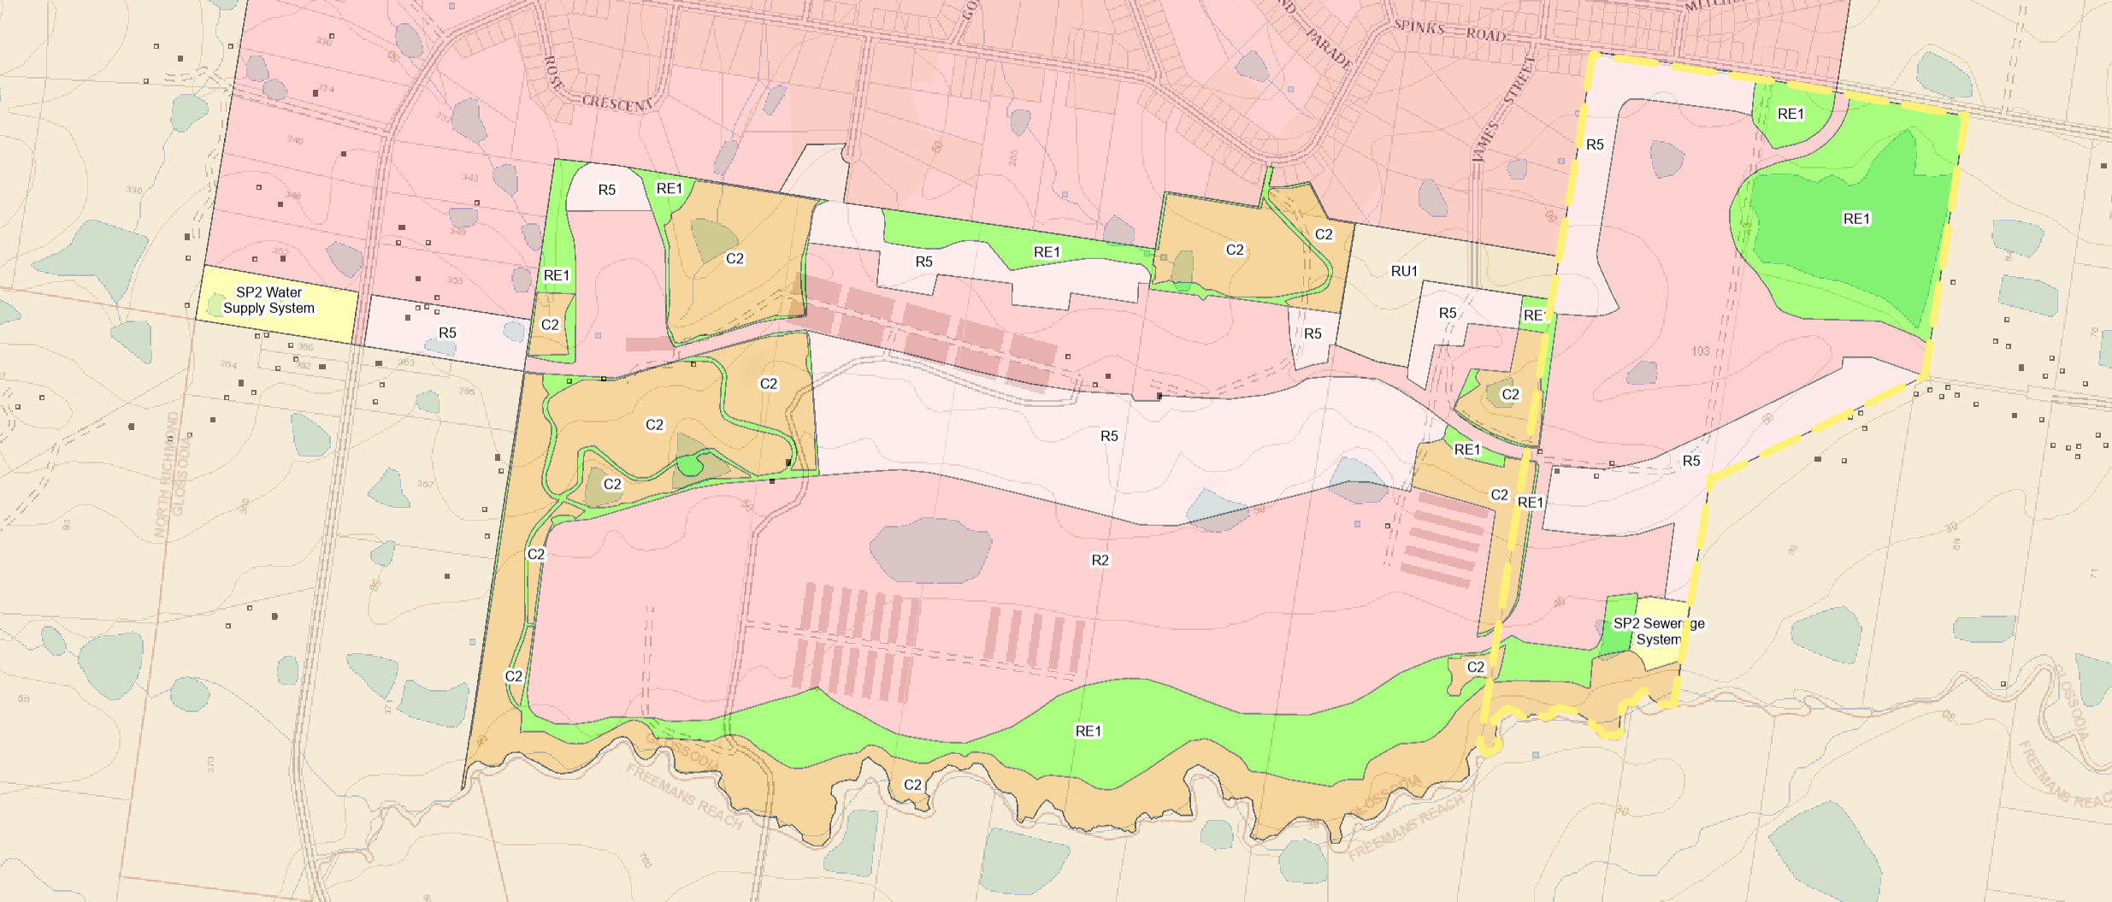
Figure 20. Zoning Map

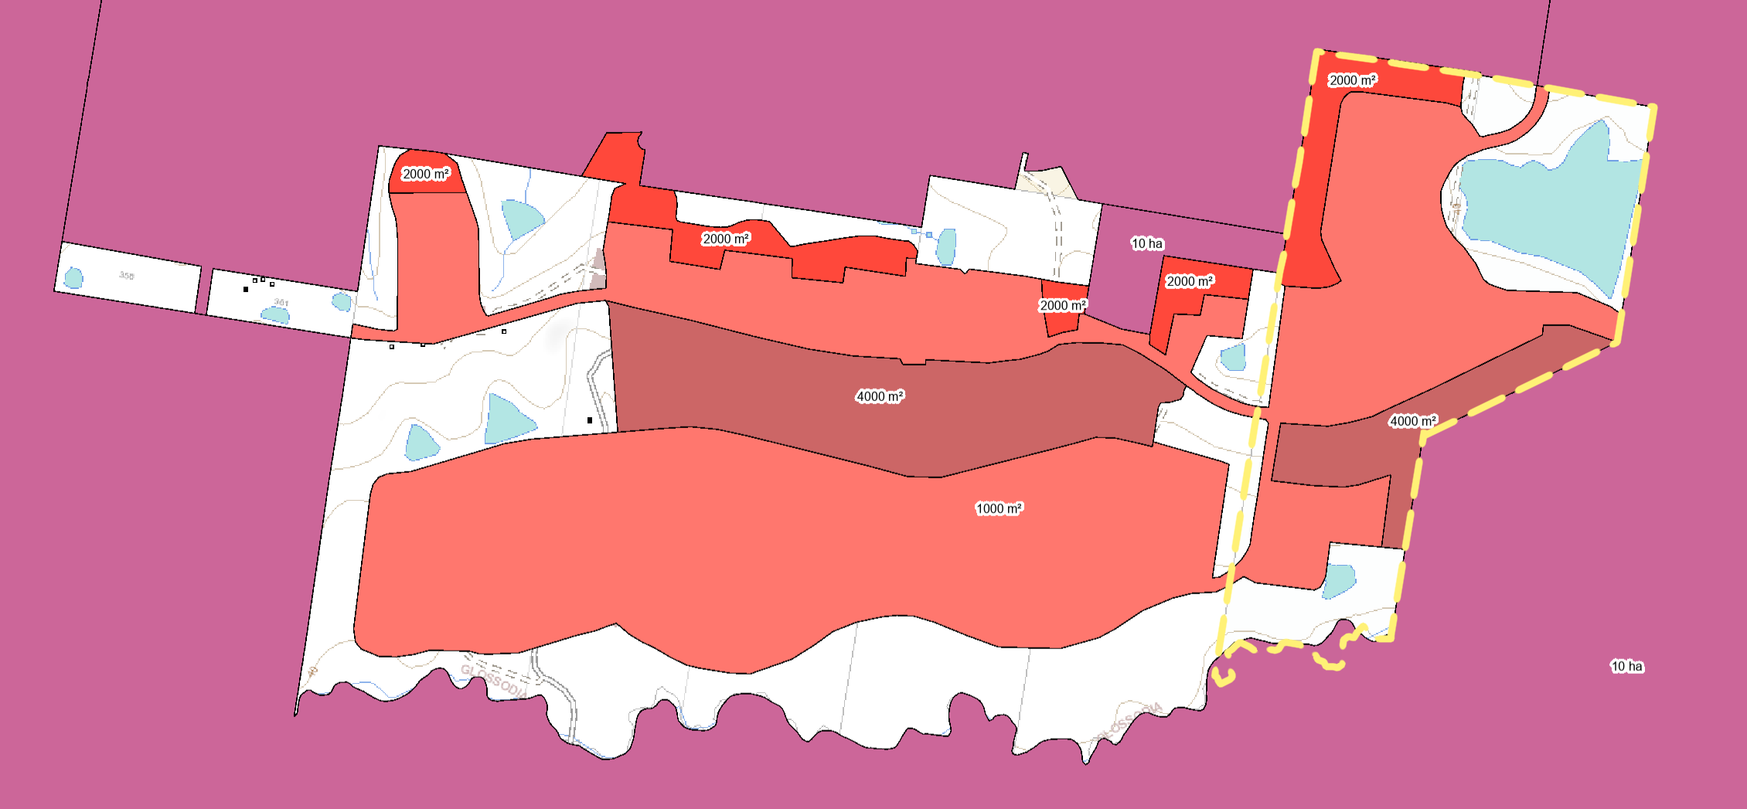
Figure 21. Lot size map

Clause | Comment
Part 4 – Principal Development Standards
Clause 4.1 – Minimum Subdivision Lot Size  Control:  R2 Low Density Residential: 1,000m²  R5 Large Lot Residential (Red): 2,000m²  R5 Large Lot Residential (Brown): 4,000m² | All lots are compliant with the lot size requirements.
Clause 4.1B – Additional requirements for Subdivision in certain rural, residential and conservation zones. | 2(a)  It is satisfied that the pattern of lots created by the subdivision are not expected to have any impact on threatened species noting the BC order on the site. Refer to section 7.3, 7.4 and 7.7 of this report.  2(b)  The lot sizes provided allow for suitable asset protection zones. Sewerage is to be serviced by the altogether group under a reticulated sewerage scheme.  2(c)  Sewerage is available.  2(d)  Council is satisfied with the depth and frontage ration with all allotments proposed.
Clause 4.1G – Restriction on the number of lots created by subdivision of certain land | The subject site is contained within this mapping with a restrictive lot yield of 580 allotments across the entire Jacaranda precinct inclusive of stage A, B, C & D.  In this respect the proposed 256 allotments identifies that there would be tie-in works with the developer of precincts A & B and as such, retains residual lot yield to be utilised within a subsequent application.
Clause 4.2B – Additional requirements for subdivisions in certain flood planning areas | All land zoned R5 Large lot residential are located above the 1:100 ARI and can be considered suitable for the erection of a dwelling house.
Part 5 – Miscellaneous provisions
Clause 5.1 - Relevant acquisition authority | The RE1 Public Recreation zoned land is not identified on the Land Reservation Acquisition Map. Dedication of land for public purposes will be addressed under the VPA.
Clause 5.10 – Heritage Conservation | An AHIP was required and executed under the concept approval. No further assessment is required as part of the subject application.
Clause 5.21- Flood risk assessment | The site is not mapped as flood prone land.
Clause 4.6 Exceptions to development standards | The proposed development does not seek any variation to development standards.
Part 6 – Additional local provisions
Clause 61 - Acid sulphate soils | The site is considered to fall under class 5 acid sulphates. Suitable conditions of consent will be provided.
Clause 6.2 - Earthworks | Council’s development engineers have reviewed the proposed earthworks involved and support the application subject to the imposition of conditions.
Clause 6.4 - Terrestrial biodiversity | The majority of the site has been Biodiversity Certified prior to the lodgement of the application. The proposed development is consistent with the BCA and order that applies to the land and as such appropriate conditions will be recommended.
Clause 6.7 - Essential Services | Appropriate conditions of consent are to be recommended for the acquisition of suitable certification of the delivery of urban infrastructure.  Water: To be delivered via Sydney water. Conditions fo consent have been imposed.  Electricity: To be delivered via Endeavour energy. Comments from the authority and conditions of consent have been provided.  Disposal and management of sewage: To be delivered by altogether group under WICA license (13_001R) via the Local Water Centre South East of the precinct under an REF application.  Stormwater drainage or on-site conservation: Council’s development engineers have reviewed the stormwater drainage system under both the current application and wholistically under the CONCEPT APPROVAL. The temporary basins are suitable in delivering a consistent staged approach to the delivery of precincts C & D.  Suitable road access: The proposed roads and intersection treatment have been reviewed and considered suitable. Appropriate conditions of consent have been imposed for the design detail to be undertaken to Council’s specifications.

9. Hawkesbury Development Control Plan 2002

A consideration of Part D Chapter 6 and 7 of the Hawkesbury Development Control Plan 2002 is provided below.

Clause | Compliance
Part D: Specific Development
7. Landfill | The earthworks are sought to permit the orderly, efficient and effect redevelopment of the site.

A site-specific chapter related to the Jacaranda site was adopted by Council on the 11 August 2021 and the considerations relevant to the application are provided below.

Clause | Compliance
Chapter E9 Jacaranda
1.0 Introduction
1.3 Development Principle and Outcomes  The following principles apply to development in Jacaranda;  - Development meets appropriate standards of character and amenity.  - Jacaranda is highly liveable for residents, with a quality public domain, access to local amenities and service, and is responsive to local environmental conditions;  - Housing is high quality and appropriately diverse to provide suitable housing for a range of households, is pleasant and comfortable to live in and responsive to the site;  - Ecologically Sustainable Development (ESD) principles including water sensitive urban design, climate responsive building design, energy efficiency, and selection/use of recycled materials where appropriate are embedded in the precinct masterplan and development outcomes.  - Significant vegetation and endangered habitats are protected in accordance with the biodiversity certification approval;  - Recreational and conservation lands incorporate areas of high value vegetation that is identified for conservation, and create continuous, high amenity and easily accessible open spaces;  - The subdivision design creates an appropriate interface with adjoining rural and residential areas, and is consistent with the semi-rural character of the area, and is responsive to the topography and ecology of the site;  - The street hierarchy and layout is legible (easy to navigate), responds to the topography, creates permeable connections throughout the site, including direct access to open spaces, and includes higher order collector streets that are suitable for buses. | The proposed development meets several development principles listed.  The delivery of housing is to be assessed within a subsequent application.
2.0 Precinct-Wide Controls
2.1.1 Place & Character | The proposed development is consistent with the structure plan under Figure 3 and table 2 of the DCP.  Ridgeline Precinct  The ridgeline precinct contains allotments delivered under the R5 Large Lot Residential precinct. All lots have a minimum lot size in excess of 4,065m².  Creekside Precinct  The proposed development seeks the subdivision of the RE1 zoned land to the south of residential allotments. These spaces are to be embellished as part of a future development application.  Bush front precinct  All lots within this precincts are either greater than 1,000m² for R2 Low Density Residential zoned land or 2,000m² for R5 Large Lot Residential zoned land.
2.2 Natural Environment Considerations
2.2.1 Contamination | Contamination has been addressed per section 7.8 of this report.
2.2.2 Cultural heritage | Cultural heritage has been addressed per section 7.5 of this report.
2.2.3 Biodiversity | All trees are to be removed within biodiversity certified areas consistent with the concept approval.
2.2.5 Riparian Corridor | DPE Water have provided their GTA as part of the concept approval. As such, the undertaking of works would be subject to a Controlled Activity Approval (CAA).  The VMP endorsed by the masterplan would be enacted under works within the CAA.
2.2.7 Bushfire Management | The concept approval endorsed an Asset Protection Zone (APZ) which are wholly retained outside of riparian zones and biobank spaces.  The application was referred to RFS who have provided their GTA for the subject application
2.3 Built Environment Considerations
2.3.1 Connectivity | The proposed road alignment is consistent with Figure 7 of the DCP and zoning of land.
2.3.2 Open Space and Public Domain | The proposed development is consistent with both Figures 7 & 9 of the DCP.  A shared pedestrian and cycle path is provided in accordance with Figure 8 on the South end of Road 1.  It is noted that the embellishment of parks and playgrounds are to be delivered under a subsequent development application.
2.3.4 Sustainability and Resilience | It is noted that PACE have entered into a commercial agreement with Altogether Group who would provide the Jacaranda precinct with recycled water for non-portable uses. Appropriate conditions have been recommended.
2.3.5 Infrastructure and Utilities | No utilities have been sought to riparian land.
2.3.6 Subdivision staging | The delivery of Precincts C & D are staged into 3 stages with 3 substages.  The stages follow a linear sequential development pattern starting from the Western interface of Spinks road at 361 Spinks Road Glossodia.
2.3.7 Development Yield | The proposed development is consistent with the concept approval  Refer to section 8.2 under Clause 4.1G of the Hawkesbury Loval Environmental Plan 2012.  The development of 256 lots is consistent with the overall yield of Precincts C & D per table 7.
Part 3 Controls for Development in the Residential Zones
3.1 Urban Design
3.1.1 Street Hierarchy, Layout and Design | The street design proposed is consistent with he indicated in Figure 22 of the DCP.
3.1.3 Street Tree planting, lighting and furniture | The proposed street trees have been reviewed by Council’s parks officer and considered as appropriate.  All electrical cables are to be undergrounded pursuant to the requirements of Endeavour energy per clause 5.
3.2 Residential Design
3.2.2 Lot size | All lots are compliant with the frontage respective to their zoning.
3.2.10 Landscaping | The proposed landscape masterplan is consistent with this clause.

10. Development Contributions

A VPA agreement was executed on the 30January 2017. The agreement was a cash contribution of $30,000 per lot delivered to the Jacaranda precinct.

On the 30July 2024, an amended VPA was provided to Council which sought to increase the contributions from $30,000 per lot to $40,735 per lot (consisting of cash and public works) to a total of $11,405,852. The items are listed as follows:

VPA Item | Type of Works | Description | Timing or Trigger for Delivery
1 | Road Work | Spinks Road upgrade from the proposed estate entry intersection to Glossodia West at 361 Spinks Road Glossodia to the Glossodia bushfire shed.  Works Comprise:  - 9.0m wide rural carriageway including new asphaltic concrete (AC) wearing course, line marking and sign posting  - Subject to Geotechnical testing, remove and replace areas of existing pavement failure  - Relocate public utilities impacted by pavement construction  - Adjust existing residential driveway crossovers, where necessary. | Within 12 months of subdivision certificate of the 201st residential lot within the development
2 | Road Work | Spinks Road and Glossodia West entry road intersection and external works on Spinks Road.  Works Comprise:  - Construction of intersection (arrangement to be agreed with Council) to provide safe entry and exit to the development.  - provide retaining walls batters in the road reserve to interface with existing properties.  - Relocate existing utility services impacted as necessary  - Adjust adjoining driveways including drainage facilities where necessary | In conjunction with the subdivision certificate of the 1st residential lot within the development
3 | Open Space Work | Precinct C: Village green on the Development Land generally in accordance with Schedule 3 including:  - Dedicated carparking  - Integrated cycle/pedestrian pathways with Australian standard lighting.  - Identify, directional and/or interpretive signage.  - Integrated fitness areas with a range of equipment.  - Formal and informal playground for all ages with appropriate shade. Playground design is to include Everyone Can Play Guidelines, as prepared by the NSW Government.  - Multi Use Games Area (MUGA)  - Picnic shelters with lighting.  - Barbeques, tables, seats, bins, bike racks and water refill stations.  Note: limited to works on existing lot 205 DP 1268299 | Within 12 months of the subdivision certificate of the 280th residential lot within the development.
4 | Open Space work | Precinct C: Currency Creek riparian corridor on the development land.  - Embellishment of the Northern Side of riparian corridor in accordance with a Vegetation Management Plan (VMP) approved by Council in DA0266/23 | Within 6 months of the subdivision certificate of the 250th residential lot within the development.
5 | Open Space work | Precinct D: village green generally in accordance with Schedule 4 including:  - Integrated cycle/pedestrian pathways with Australian Standard lighting  - Identity, directional and/or interpretive signage  - Informal kickabout space (turf) that can be utilised for sporting activities  - Integrated fitness areas with a range of equipment  - Picnic shelters with lighting  - Barbeques, tables, seats, bins, bike racks and water refill stations. | Within 12 months of the subdivision certificate of the 150th residential lot within the development
6 | Open Space work | Precinct D: Passive recreation nodes 1 & 2 generally in accordance within Schedule 5 including:  - Passive Recreation – Node 1  - Identity, directional and/or interpretive signage  - Informal playground for all ages with appropriate shade.  - Informal gathering area with seating and bins.  - Integrated fitness area for small groups  - Passive Recreation – Node 2  - Identity, directional and/or interpretive signage.  - Integrated fitness areas with a range of equipment  - Informal gathering area with seating and bins. | Within 6 months of the subdivision certificate of the 100th residential lot within the development.
7 | Open Space work | Precinct D: Currency Creek riparian corridor  - Embellishment of the Northern side of riparian corridor in accordance with a Vegetation Management Plan (VMP) approved by Council in Da0266/23 | Within 6 months of the subdivision certificate of the 200th residential lot within the development.
8a | Community works | - Pedestrian crossing, 2 bus stops, cycleway | Concurrent with subdivision works
8b | Cash Contribution | - $900 per lot | Prior to the issue of a Subdivision certificate.

Whilst not formally executed, the VPA is to be reported to Council shortly and will supersede the existing VPA arrangement.

Notwithstanding the above, the existing VPA is active and therefore the application can be determined on this basis.

11. Environmental Planning and Assessment Regulations 2021

Applicable regulation considerations for compliance with the Building Code of Australia, PCA appointment and notice of commencement of works, sign on work sites, critical stage inspections and records of inspection will be covered under the recommended conditions of consent.

14. Suitability of the Site

The development site is considered suitable for the proposed development as:
- it has been rezoned for urban development;
- The proposal will facilitate future urban development and contribute to Council housing targets;
- it will ultimately facilitate additional housing to meet the housing demands of the Hawkesbury;
- it is free of any significant constraints to the proposed development;
- it is readily accessible;
- the proposed concept is consistent with the established strategic planning objectives for the site; and
- the development improves the environmental conditions on the Site through the remediation works proposed.

15. Public Consultation

In accordance with Council’s Community Participation Plan 2019, the Development Application was notified for a period of 28 days from the 28 October 2024 to 25 November 2024. In response three (3) submissions were received. The issues raised within those submissions are addressed below. Issues have been grouped to avoid repetition.

Issue | Response
Dam-dewatering | Dam dewatering is not sought under this application but has been approved under the concept approval.  Council’s development engineers and Water NSW have reviewed the dam dewatering under the concept approval and have imposed conditions of consent.
Bus stops | The indicative location of bus stop are as below per the submitted traffic report prepared by SCT Consulting.  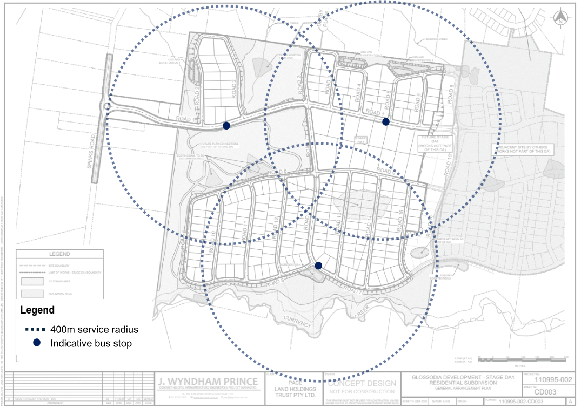
Safety design for the proposed roundabout | The proposed roundabout has been designed in accordance with the relevant Australian standards and Council’s design specifications.  Kerb and gutter is sought under the VPA works along Spinks Road.  No changes to speed limits are feasibly under this Development Application nor are proposed.
Security | Temporary site safety fencing is to be installed in accordance with the relevant construction standards.
Environmental Pollution concerns | A Construction Environmental Plan is to be provided prior to works commencing. These will generally follow the same principles endorsed under the concept approval.
Improvements to existing conditions requested. | Access to the altogether group local water centre is at the discretion of altogether group and their WICA license.  Footpaths will be delivered along Spinks Road in accordance with the VPA. Pedestrian crossing are provided as part of the delivery of the roundabout design.  Electrical infrastructure is sought to be undergrounded as per Endeavour energy guidelines.
Traffic movements resulting from the development | A traffic impact assessment was considered as part of the original Planning Proposal and the concept approval.  A traffic impact assessment was also provided as part of this subject development application. The documents was provided to both Council’s development engineers and TfNSW who have raised no objections to the proposed development.

16. Public Interest

The site is considered to have generally satisfied both Council’s and external stakeholder requirements and has been the culmination of several planning proposal prior to the submission of this Development Application and a Concept Development Application under DA0266/23. In this regard, Council considers that the proposed development has been developed in line with the key objectives of the Planning Proposal, Concept Masterplan, Development Control Plan and other such requirements and therefore concludes that the application remains in the public interest.

17. Conclusion

The application has been assessed relative to Section 4.15 of the Environmental Planning and Assessment Act 1979, taking into consideration all relevant state and local planning controls.

Having regard to the assessment of the proposal, Council officers are satisfied that the proposed development has been appropriately designed and will provide a suitable service to the public. It is considered that the proposal sufficiently minimises adverse impacts on the amenity of neighbouring properties.

The proposed development has been assessed having regard to the relevant planning controls and represents a form of development contemplated by the relevant statutory and non-statutory controls applying to the land. On balance, the proposal has demonstrated a satisfactory response to the objectives and controls of the applicable planning framework.

For these reasons, it is considered that the proposal is satisfactory having regard to the matters for consideration under Section 4.15 of the Environmental Planning and Assessment Act 1979 and is recommended for approval, subject to conditions.

19. Recommendation

Pursuant to Section 4.16 of the Environmental Planning and Assessment Act 1979, that:

- Pursuant to Section 4.16 of the Environmental Planning and Assessment Act 1979, the Sydney Western City Planning Panel grant development consent to DA0409/24 for a period of five (5) years within which physical commencement is to occur from the date on the Notice of Determination, subject to conditions of consent.
The reasons for the conditions imposed on this application are as follows:

- To facilitate the orderly implementation of the objectives of the Environmental Planning and Assessment Act 1979 and the aims and objectives of the relevant Council Planning instrument.
- To ensure that the local amenity is maintained and is not adversely affected and that adequate safeguards are incorporated into the development.
- To ensure the development does not hinder the proper and orderly development of the subject land and its surrounds.
- To ensure the relevant matters for consideration under Section 4.15 of Environmental Planning and Assessment Act 1979 are maintained.

- That those who made a submission be advised of the Panel’s determination.

Report prepared by

Matthieu Santoso
Senior Town Planner
Hawkesbury City Council

